Creating a new environment for MISO DEV

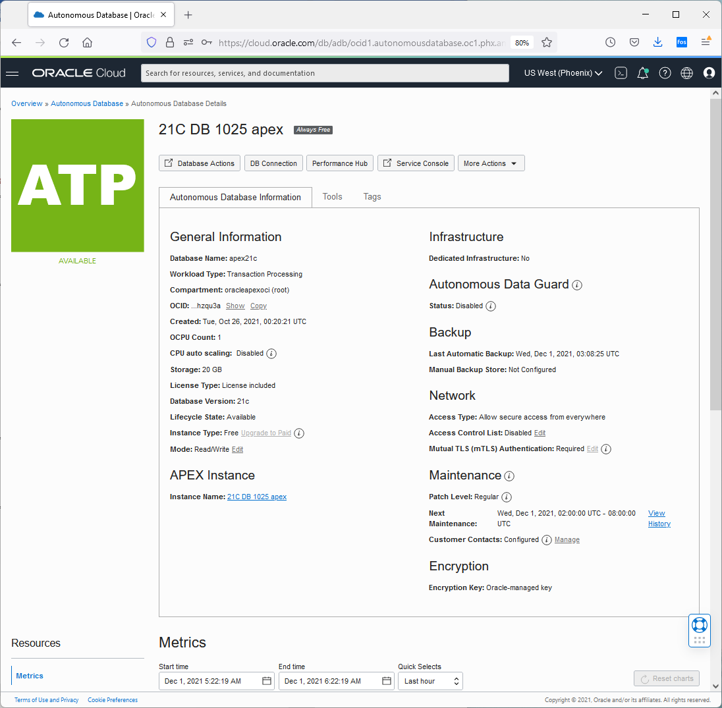

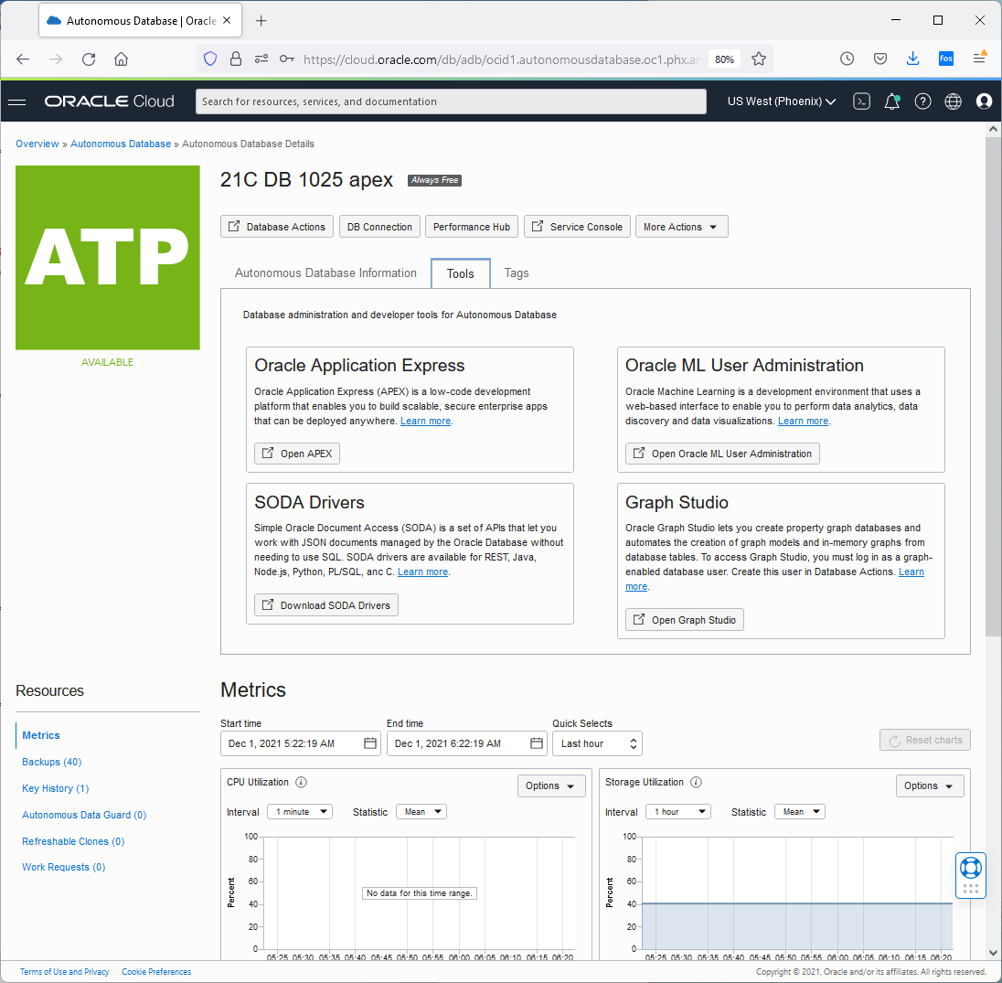

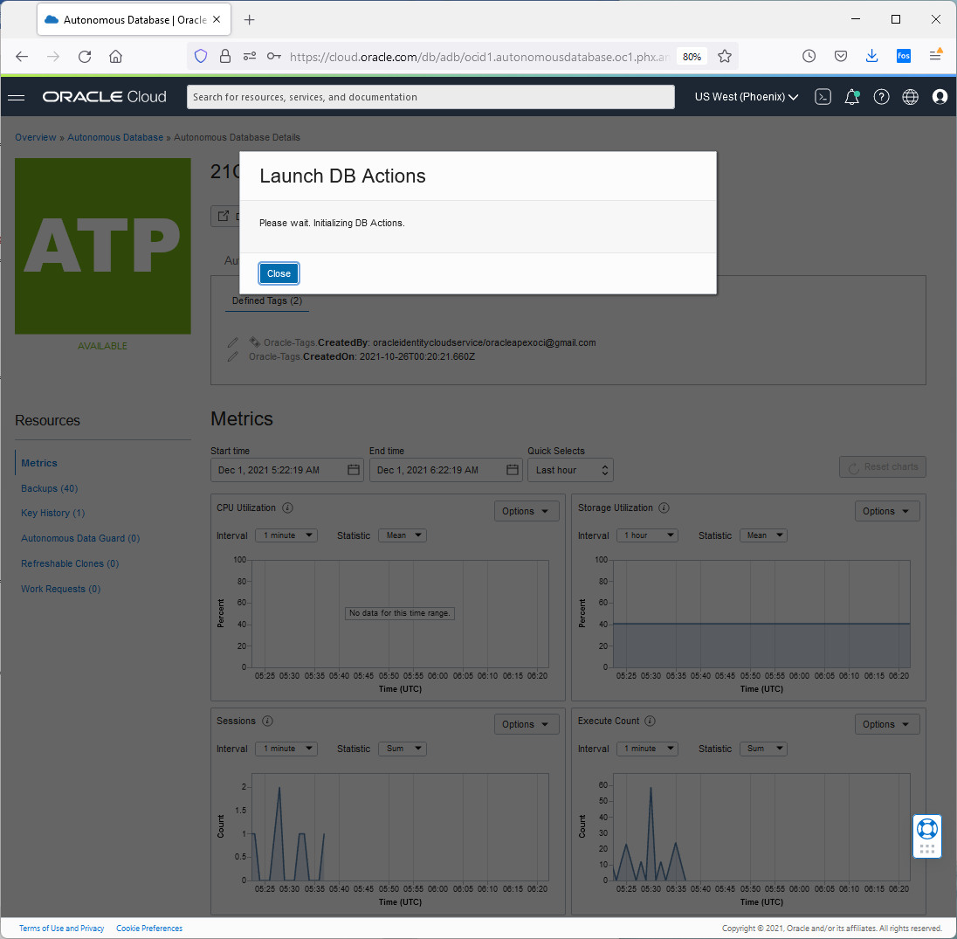

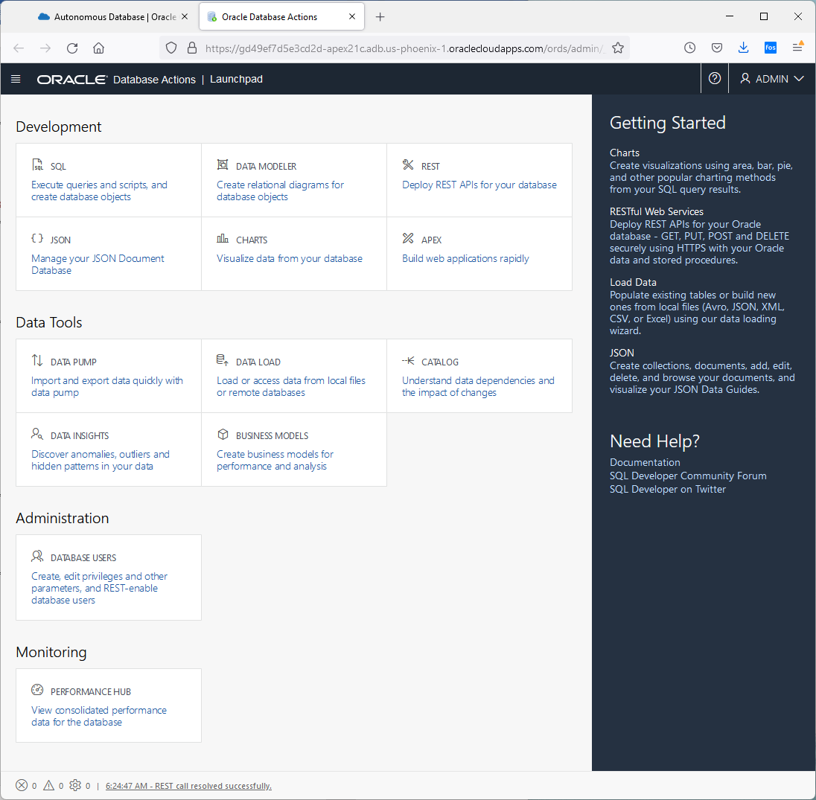

Click on Administration database users

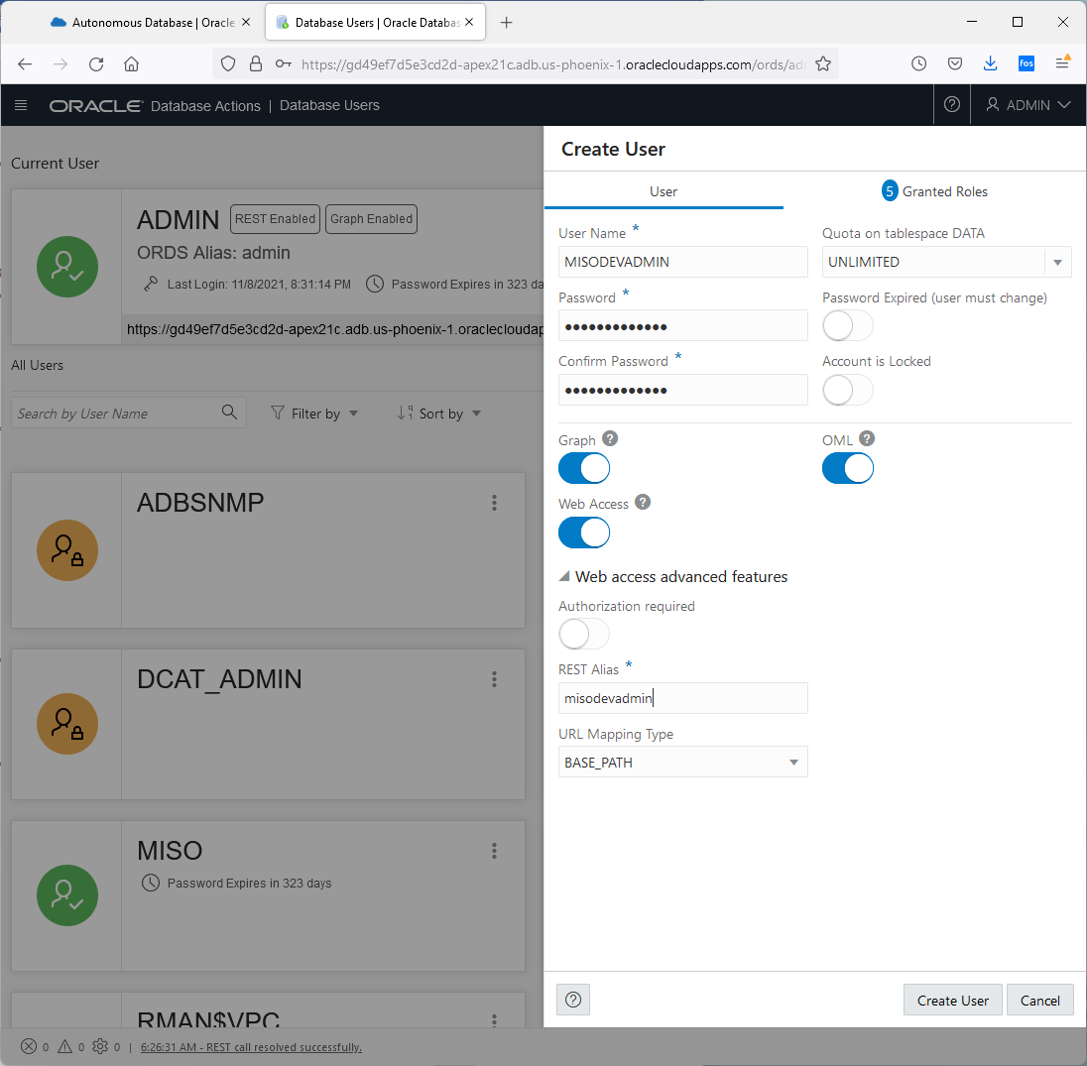

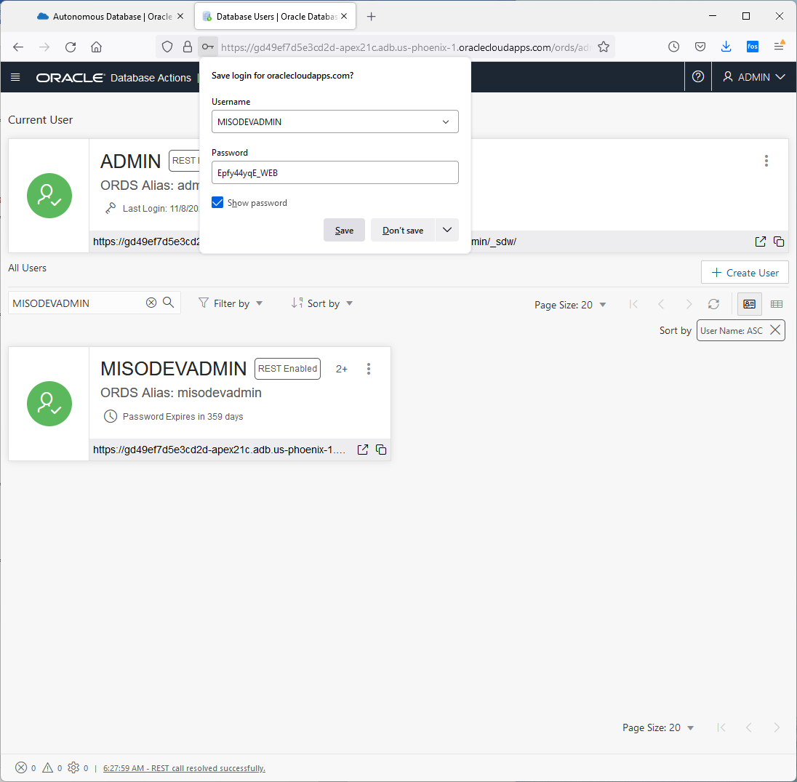

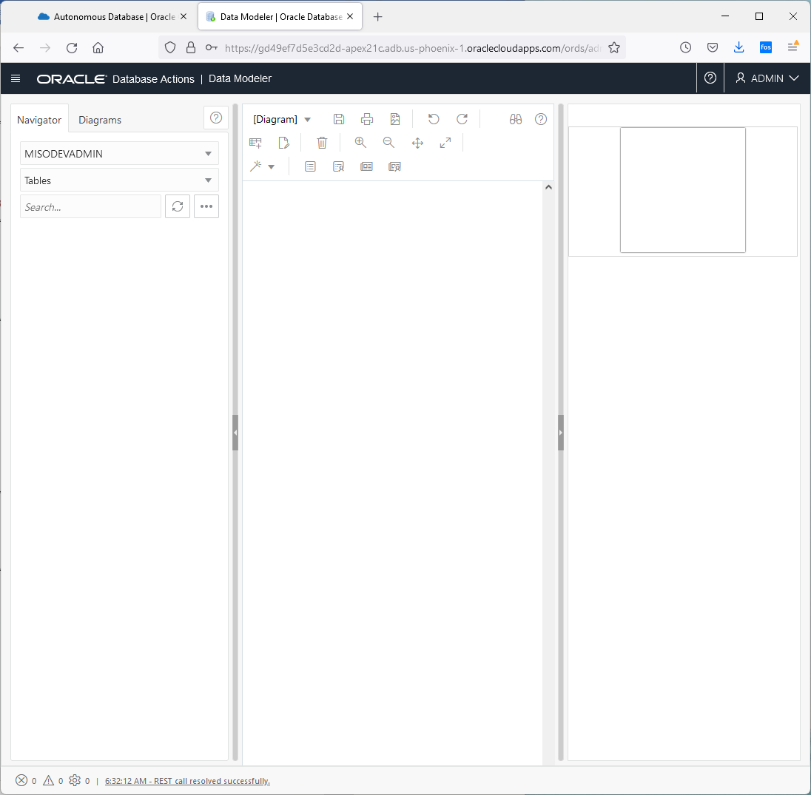

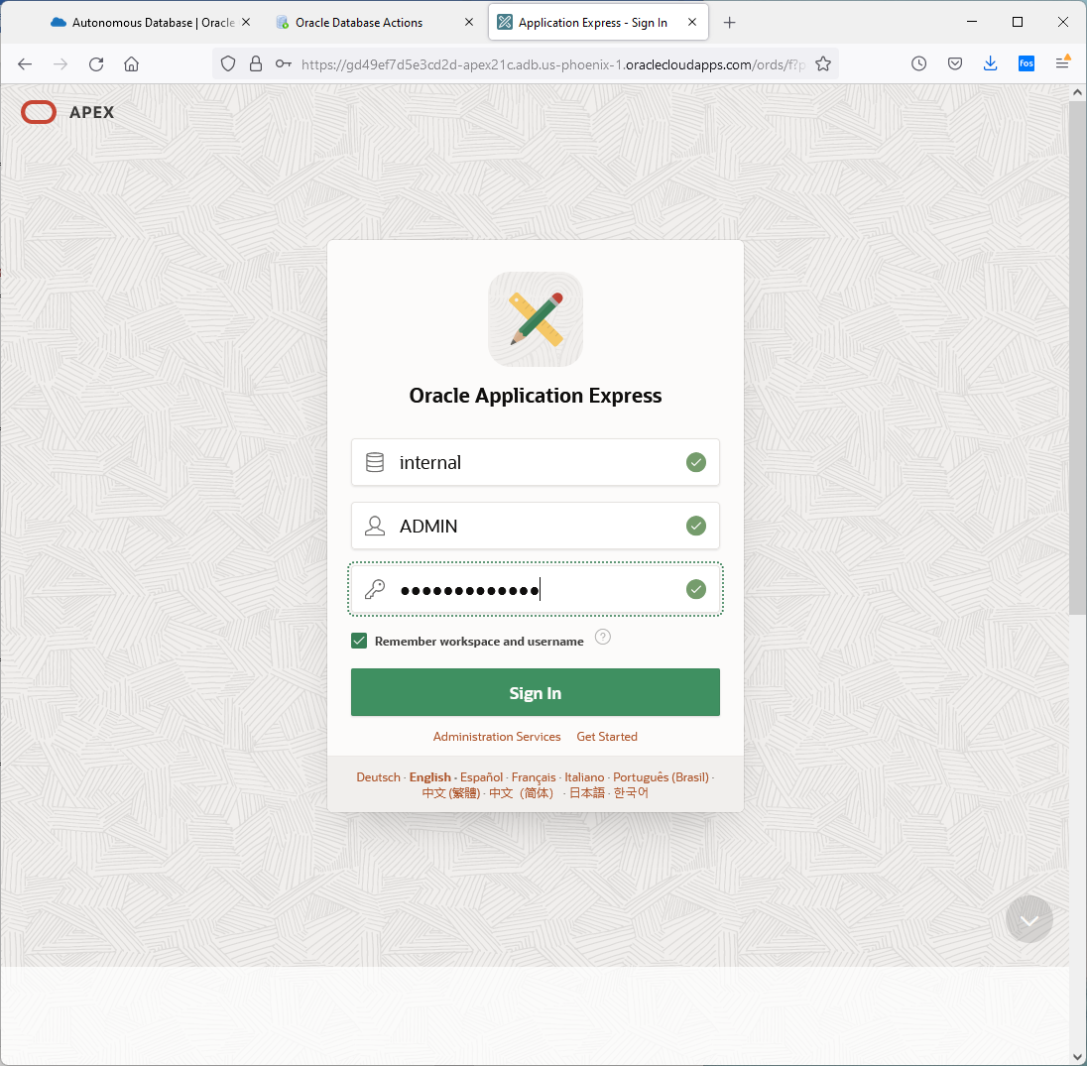

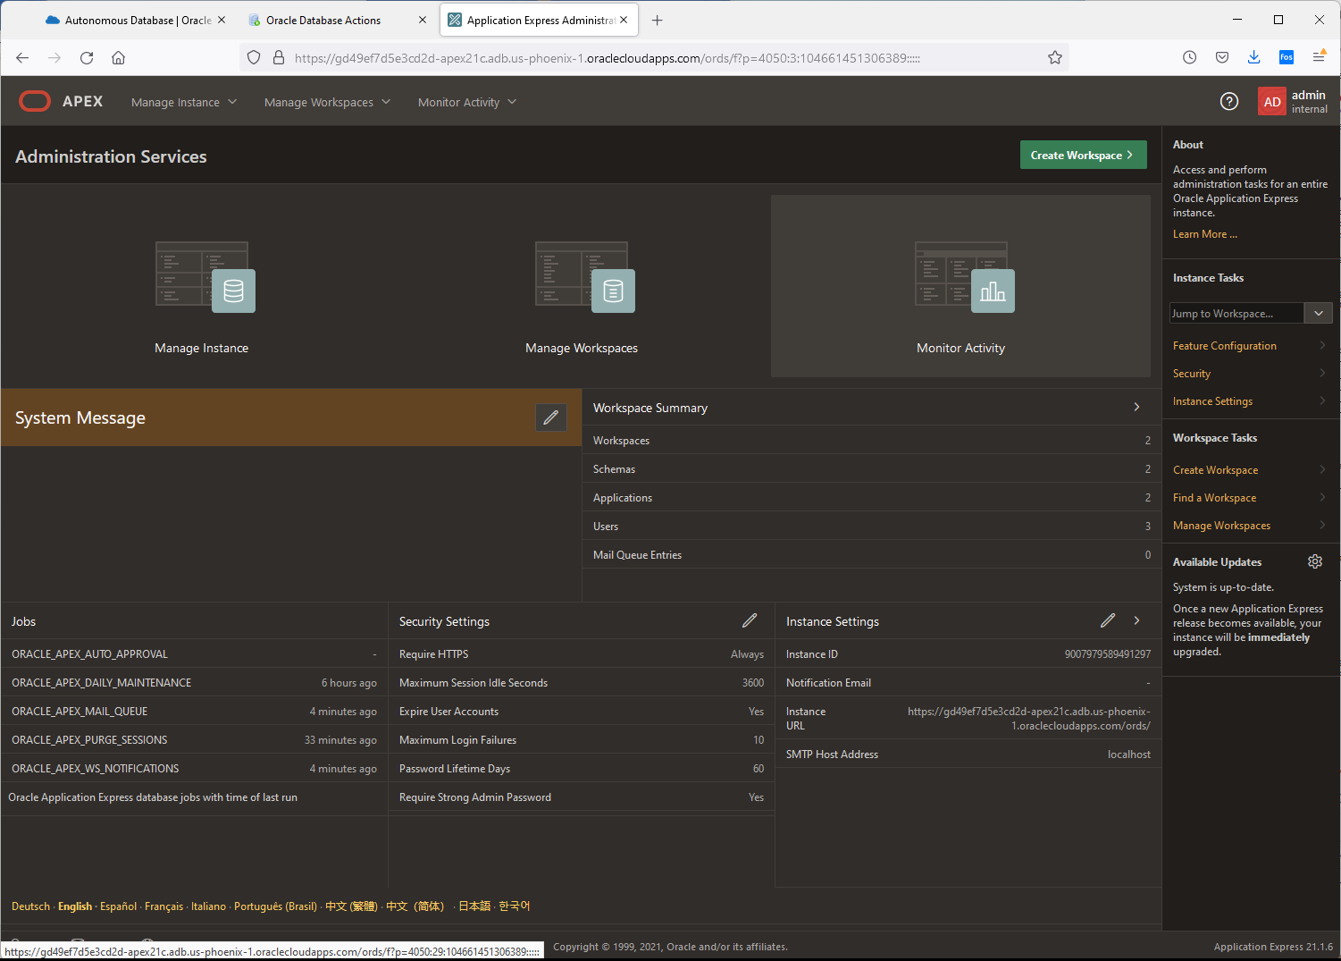

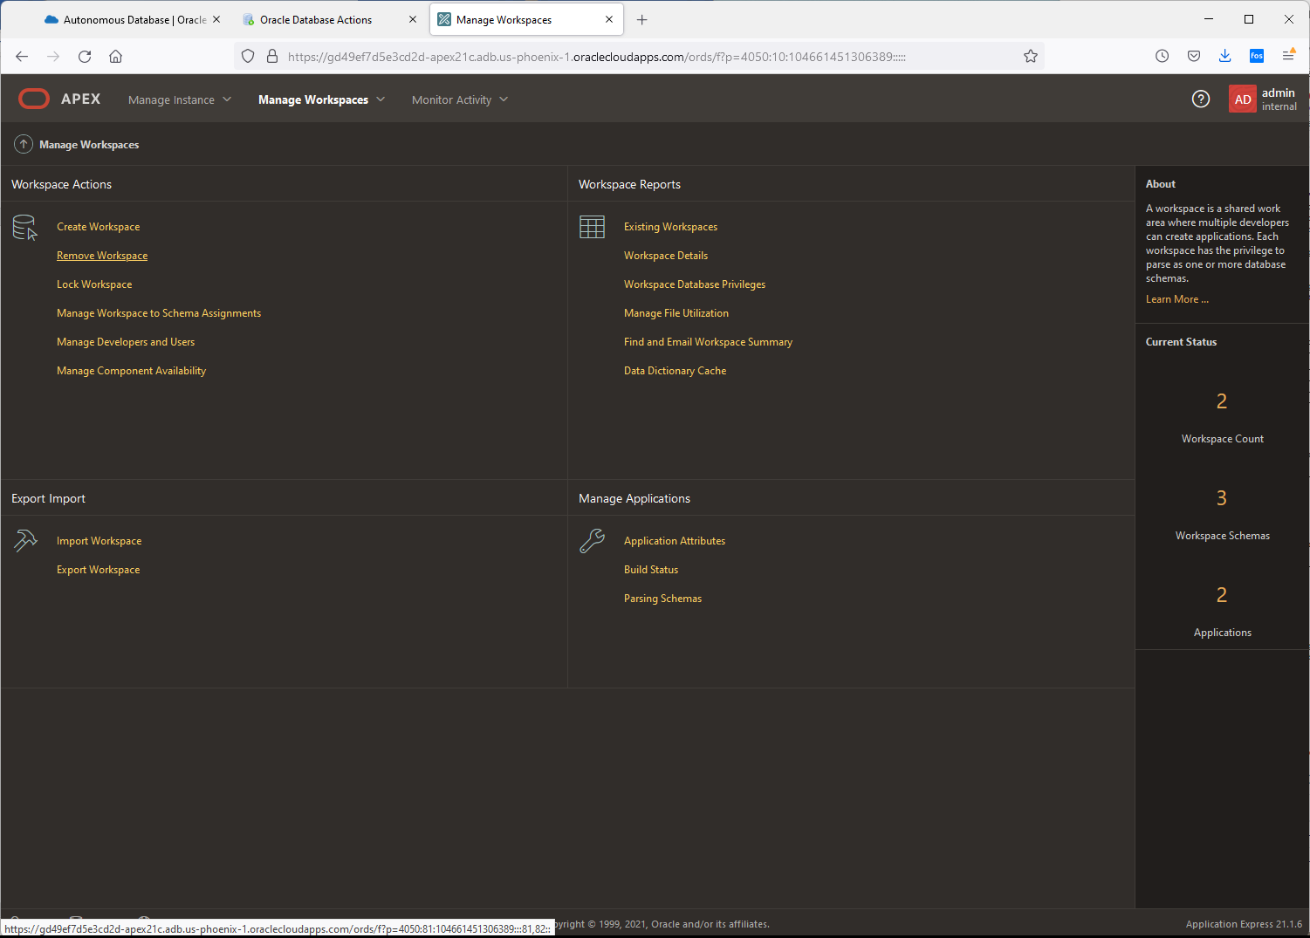

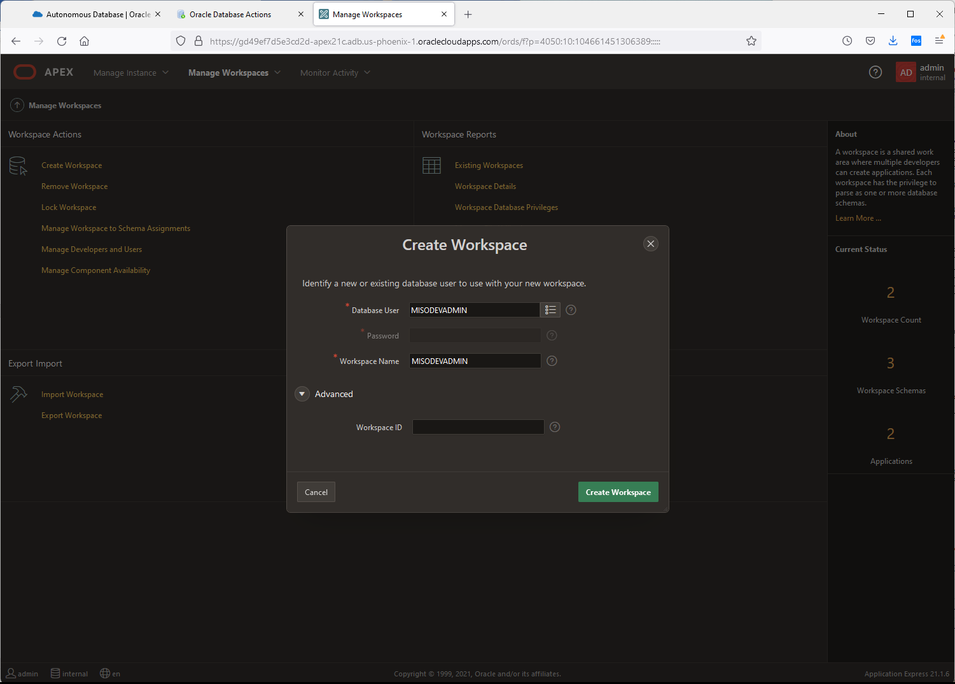

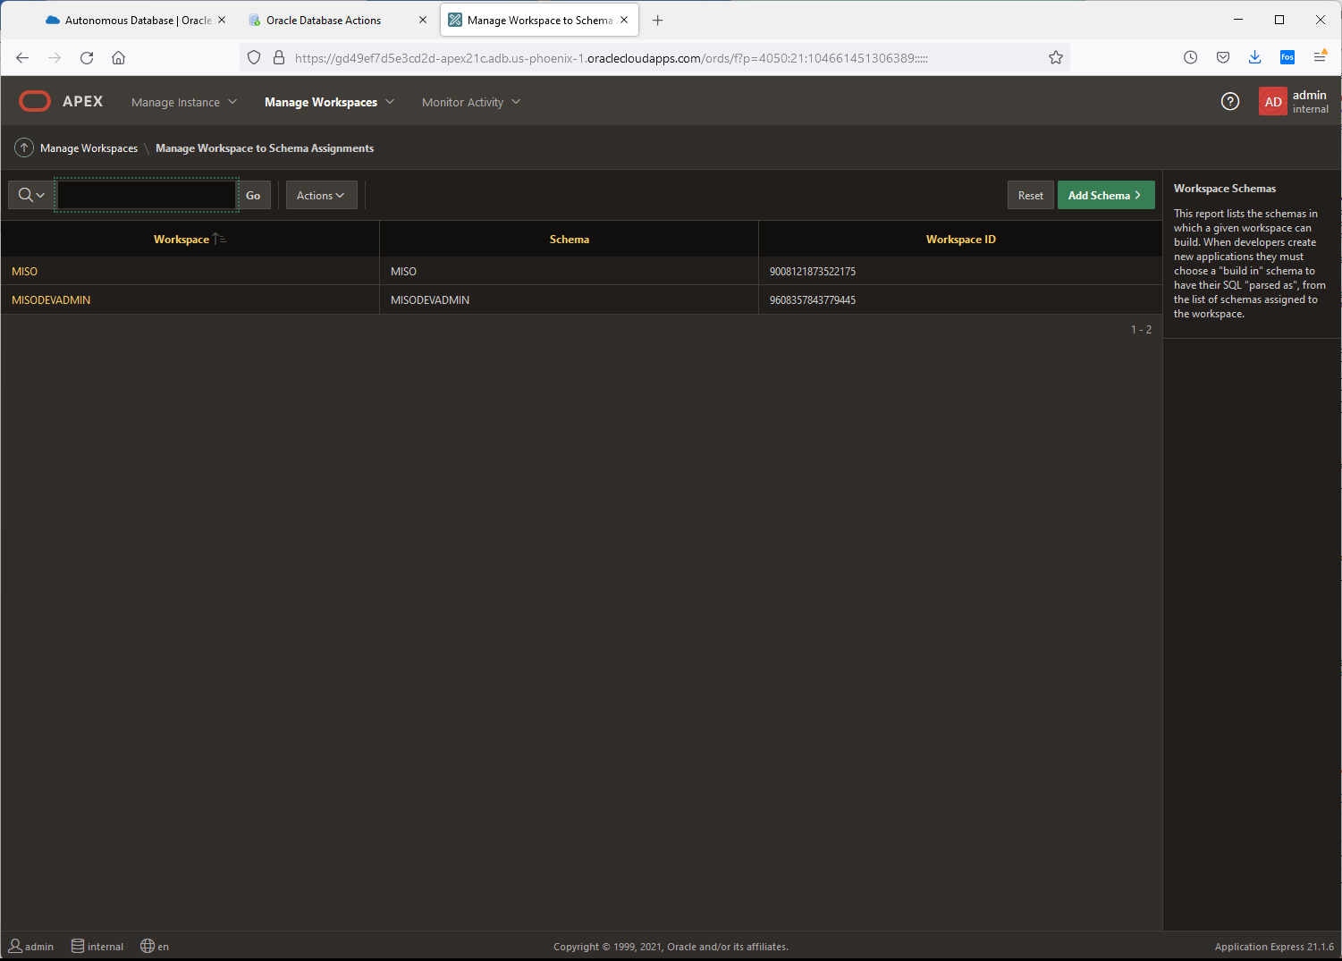

Users created nkosolobov/MisoSoup123!@#

Users created rsinnet/MisoSoup123!@#

Users created aplascencia/MisoSoup123!@#

<https://gd49ef7d5e3cd2d-apex21c.adb.us-phoenix-1.oraclecloudapps.com/ords>

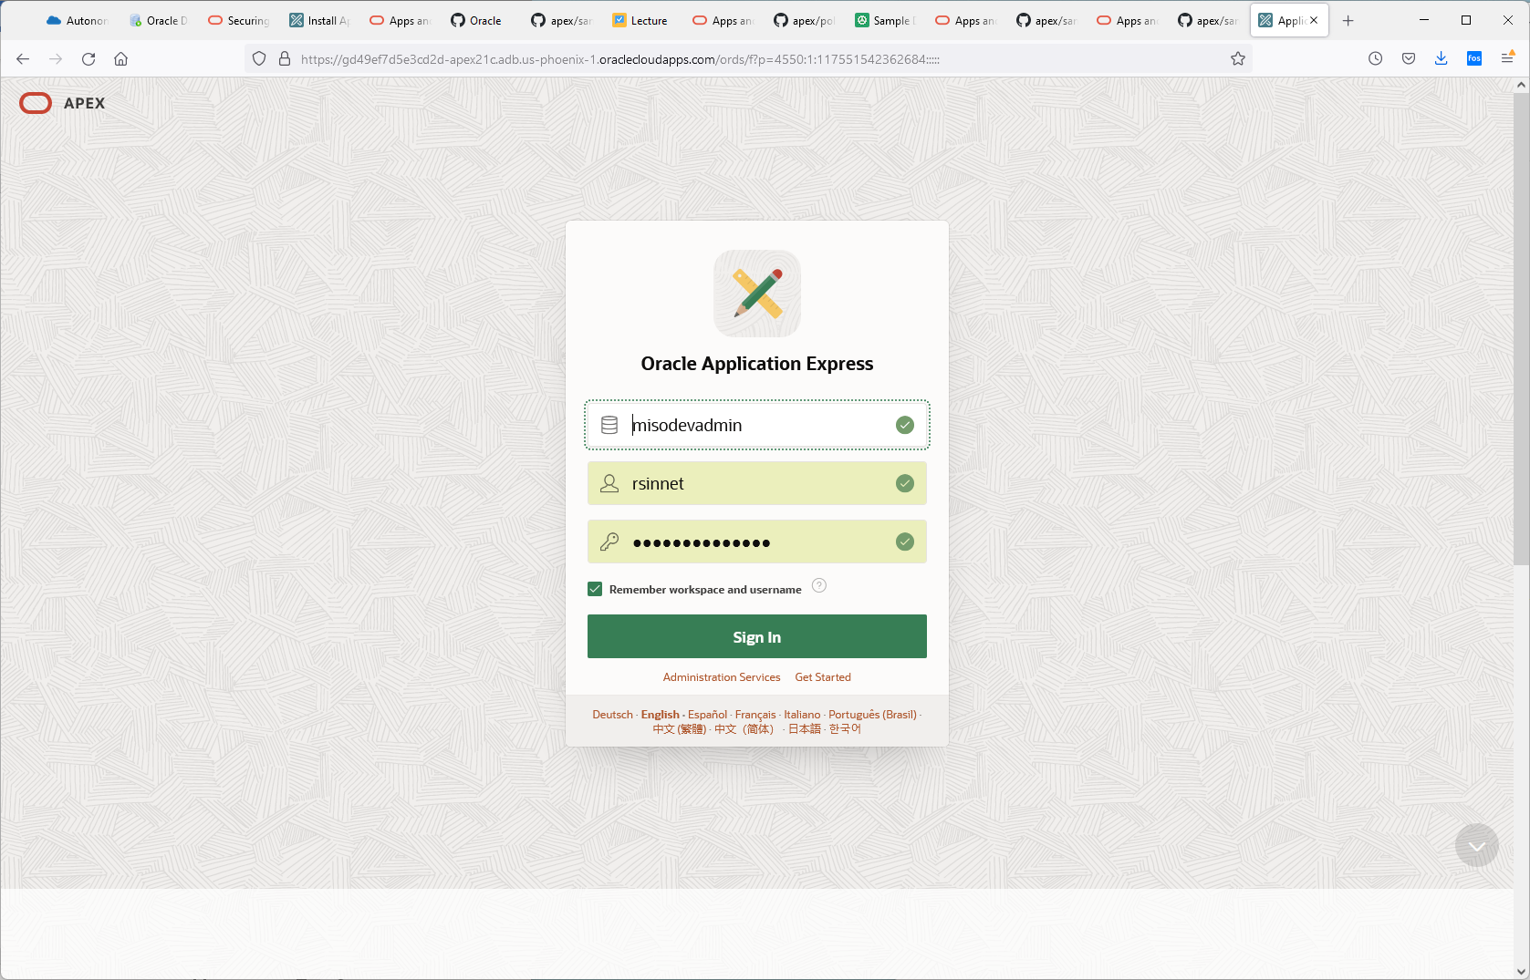

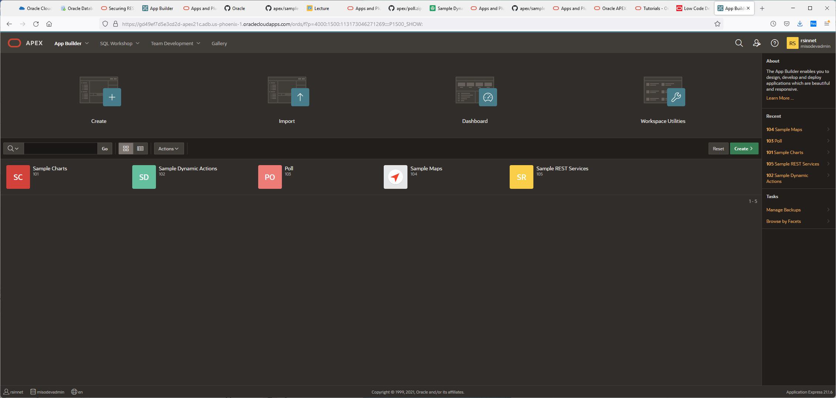

1. From your APEX workspace home page, click **App Builder**.
2. Click **Create a New App**.

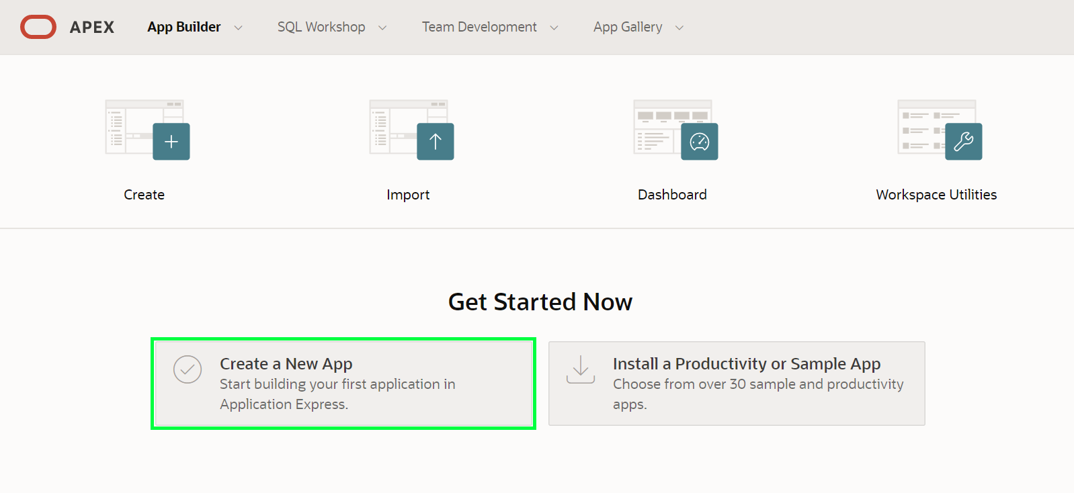

1. Click **From a File**.

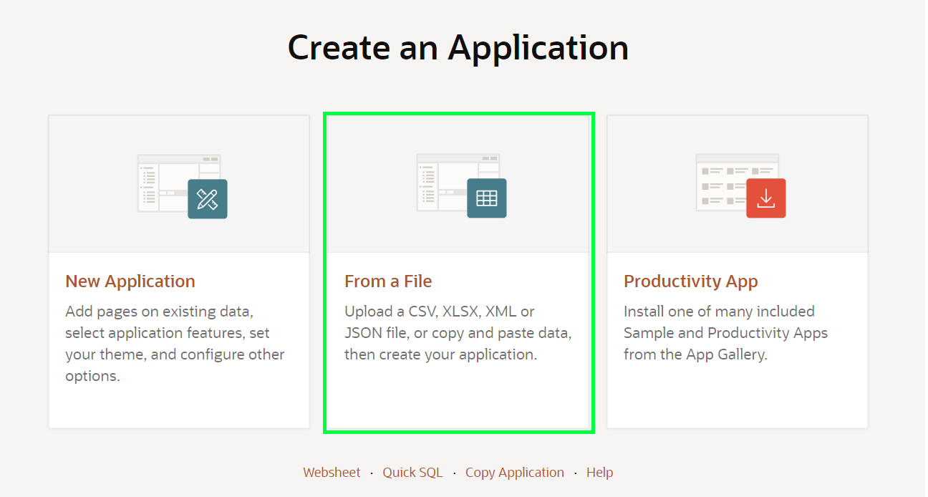

When creating an application from a file, APEX allows you to upload CSV, XLSX, XML, or JSON files and then build apps based on their data. Alternatively, you can also copy and paste CSV data or load sample data.

1. Within the Load Data wizard, click the **Copy and Paste** option at the top.

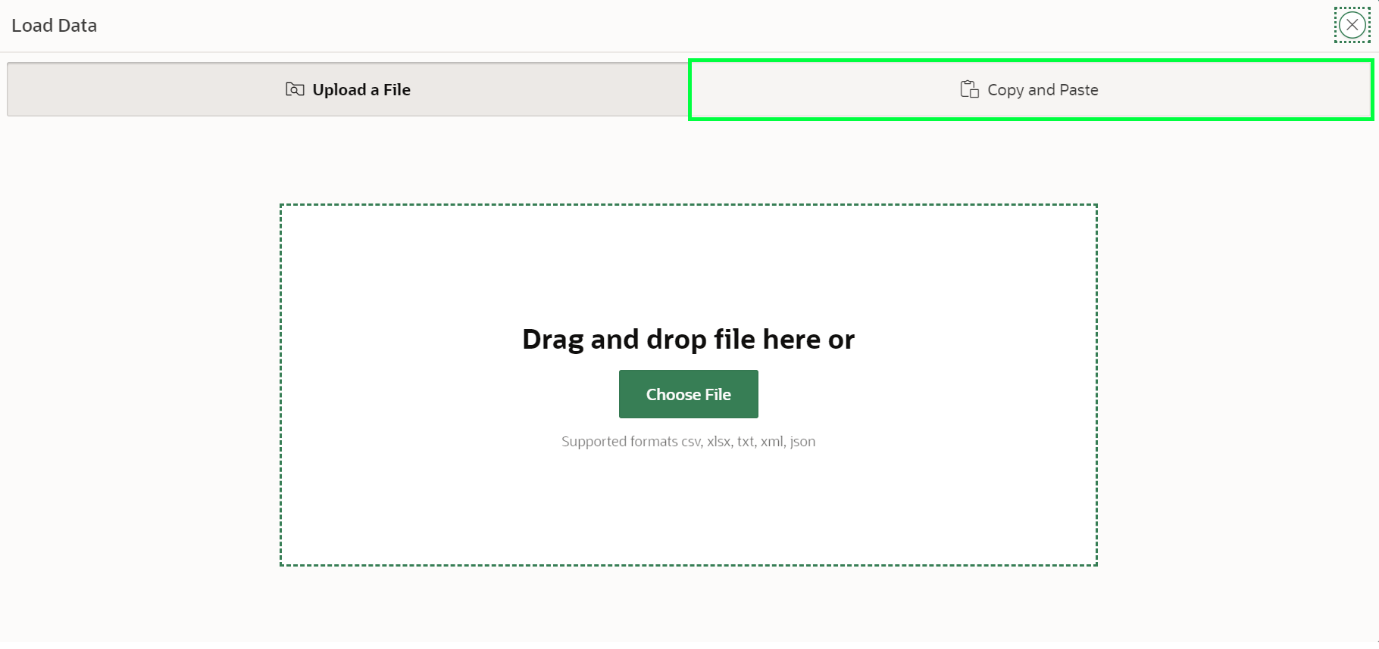

1. Select **Project and Tasks** from the sample data set list and then click **Next**.

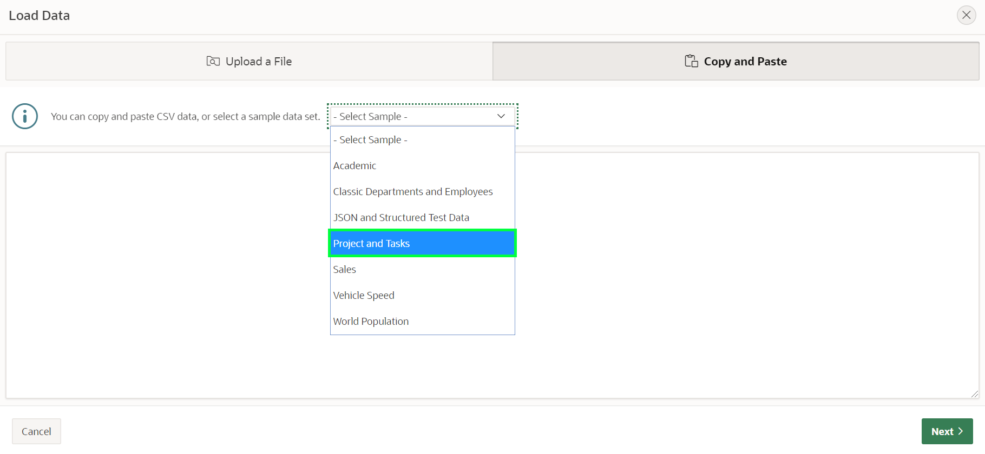

1. Review the parsed data. Enter **PROJECT_TASKS** for Table Name and Click **Load Data**.

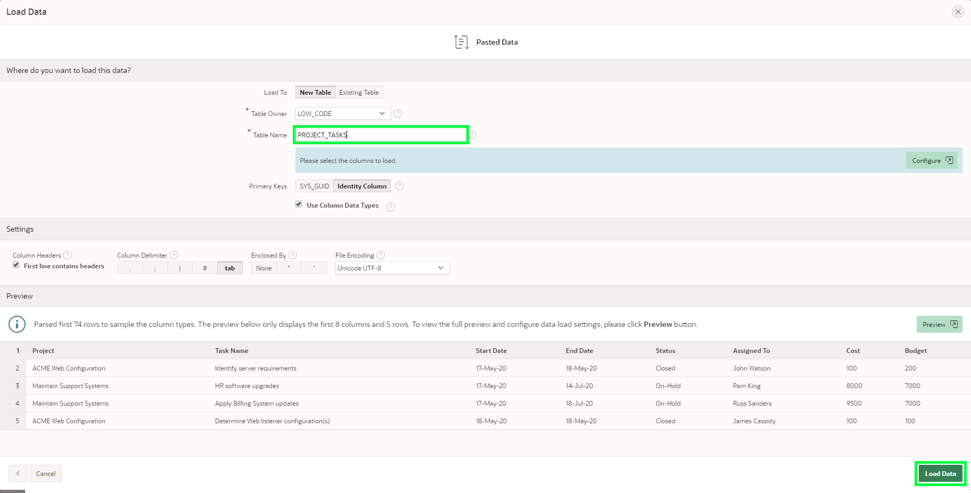

After clicking **Load Data** you will see a spinner until the wizard finishes loading the data. Continue to Part 2 at that point.

**Task 2: Creating an application**

The Data Load wizard has created a new table and populated that table with the records from the sample data. Now you can create an app based on this new table.

1. In the Load Data dialog, verify that 73 rows have been loaded into the **PROJECT_TASKS** table, then click **View Table**.

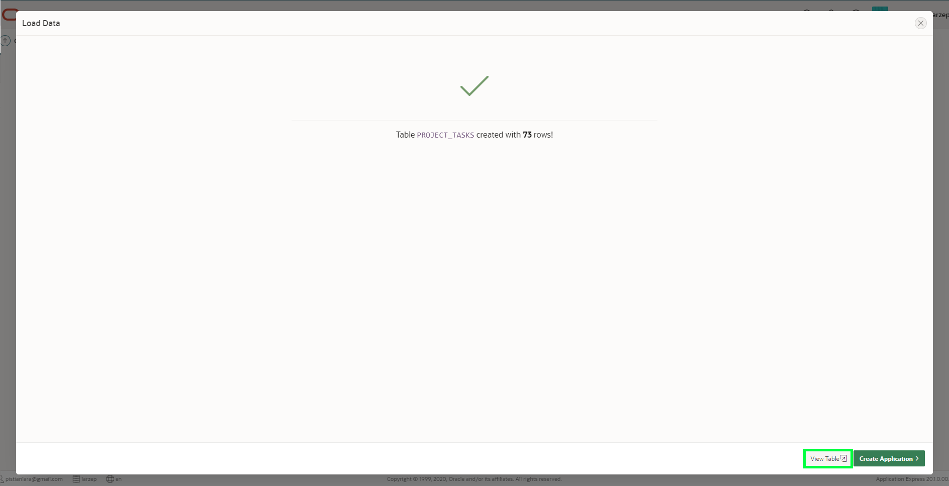

1. In the Object Browser, review the table structure.  
   In the Table toolbar, click **Create App**.

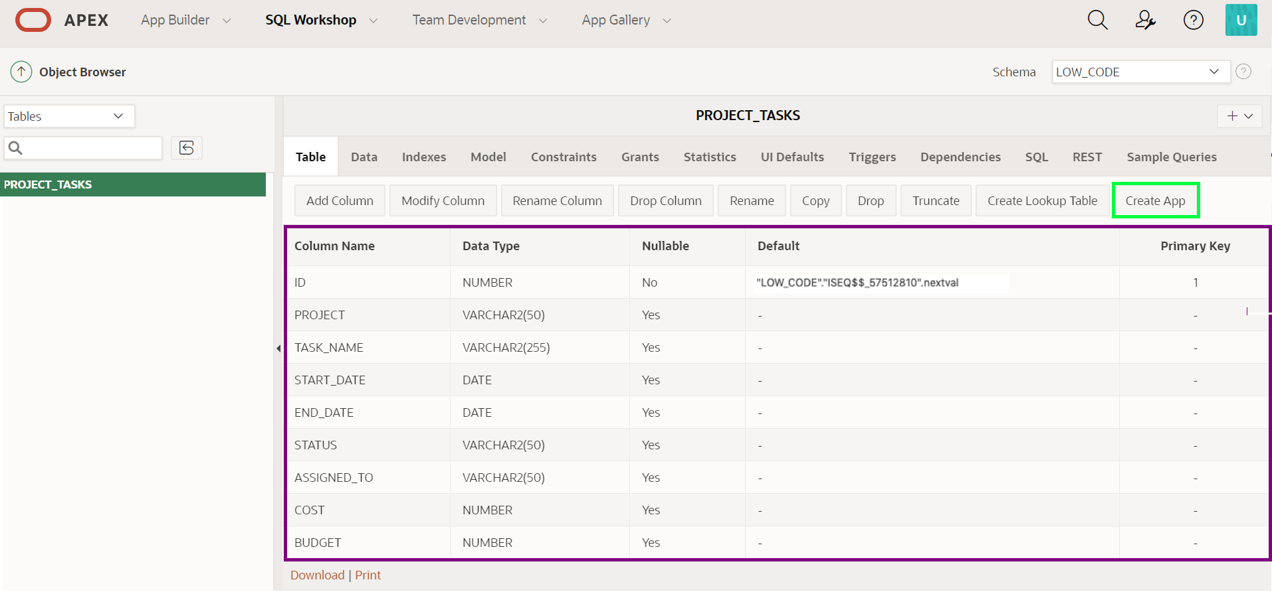

1. On the Create Application page, click **Create App**.
2. In the Create Application page, review the pages listed. Click the **Edit** button for a page to review more details.

Click **Check All** for Features, and then click **Create Application**.

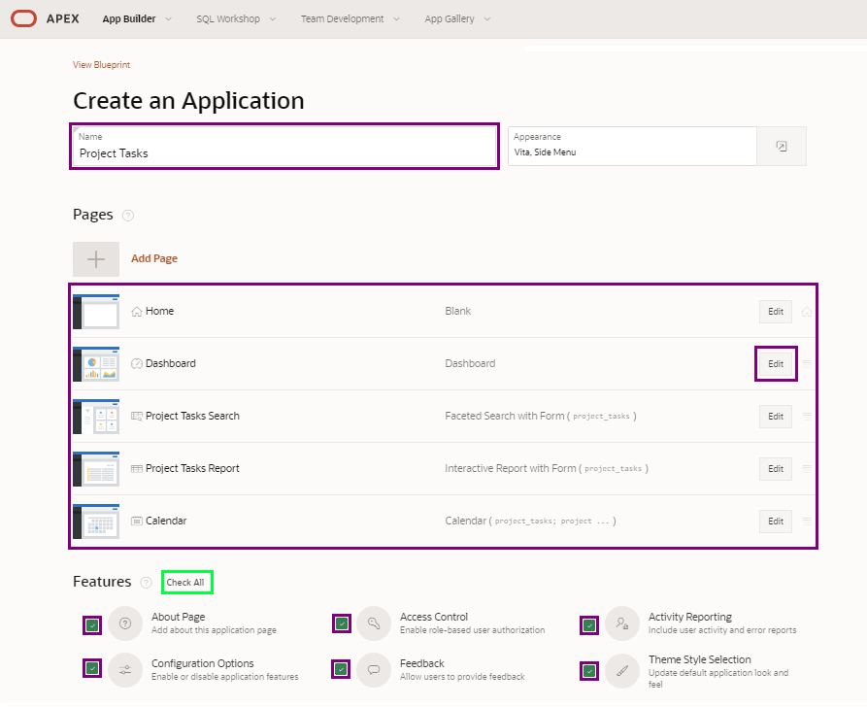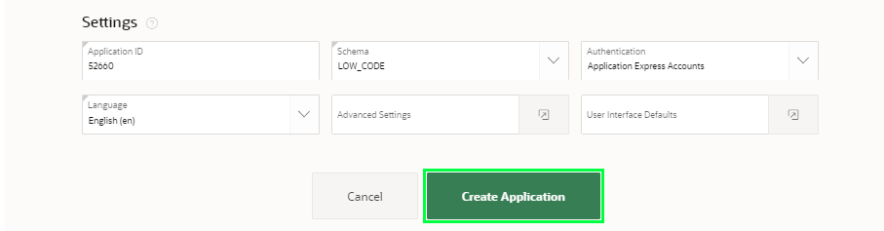

When the wizard finishes creating the application, you will be redirected to the application's home page in the App Builder.

**Task 3: Running and exploring the new app**

1. Click **Run Application**. This will open the runtime application in a new browser tab, allowing you to see how end users will view the app.

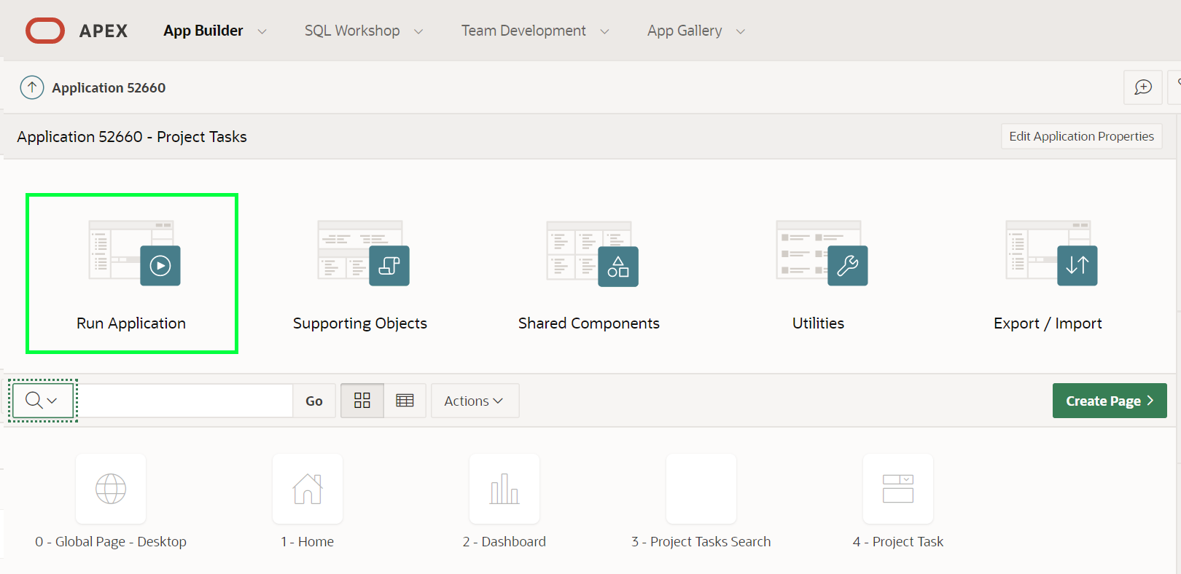

1. Enter your user credentials and click **Sign In**.

*Note: Use the same Username and Password you used to sign into the APEX Workspace.*

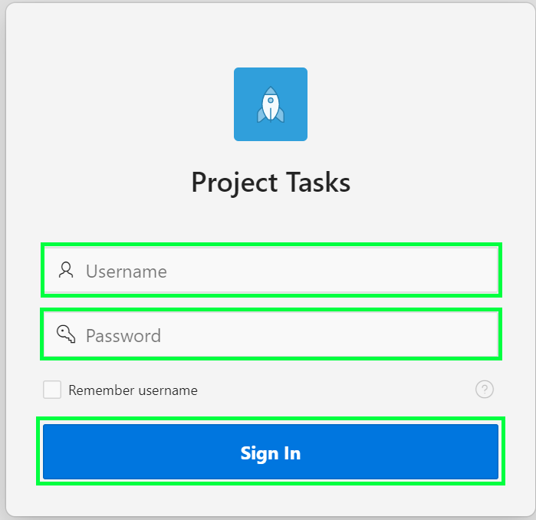

1. Click on the navigation menu icon to expand the navigation menu 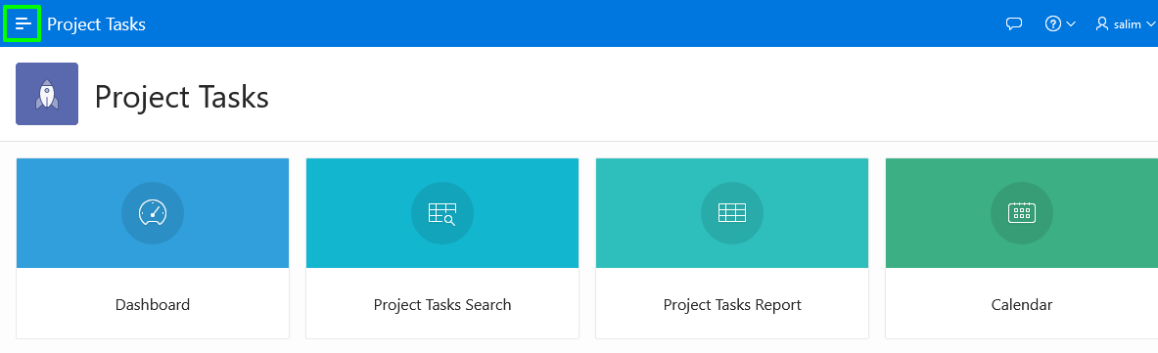
2. Explore the application a little. Click **Dashboard** (in the home menu or the navigation menu) to view the charts created. Click **Project Tasks Search**, in the navigation menu, to play with the faceted search. Click **Project Tasks Report** to view an interactive report, then click the edit icon for a record to display the details in an editable "form" page. Next, navigate to the **Calendar** page and review the data displayed (*Note: You may need to scroll back several months to see data*). Finally, review the options available under **Administration**.

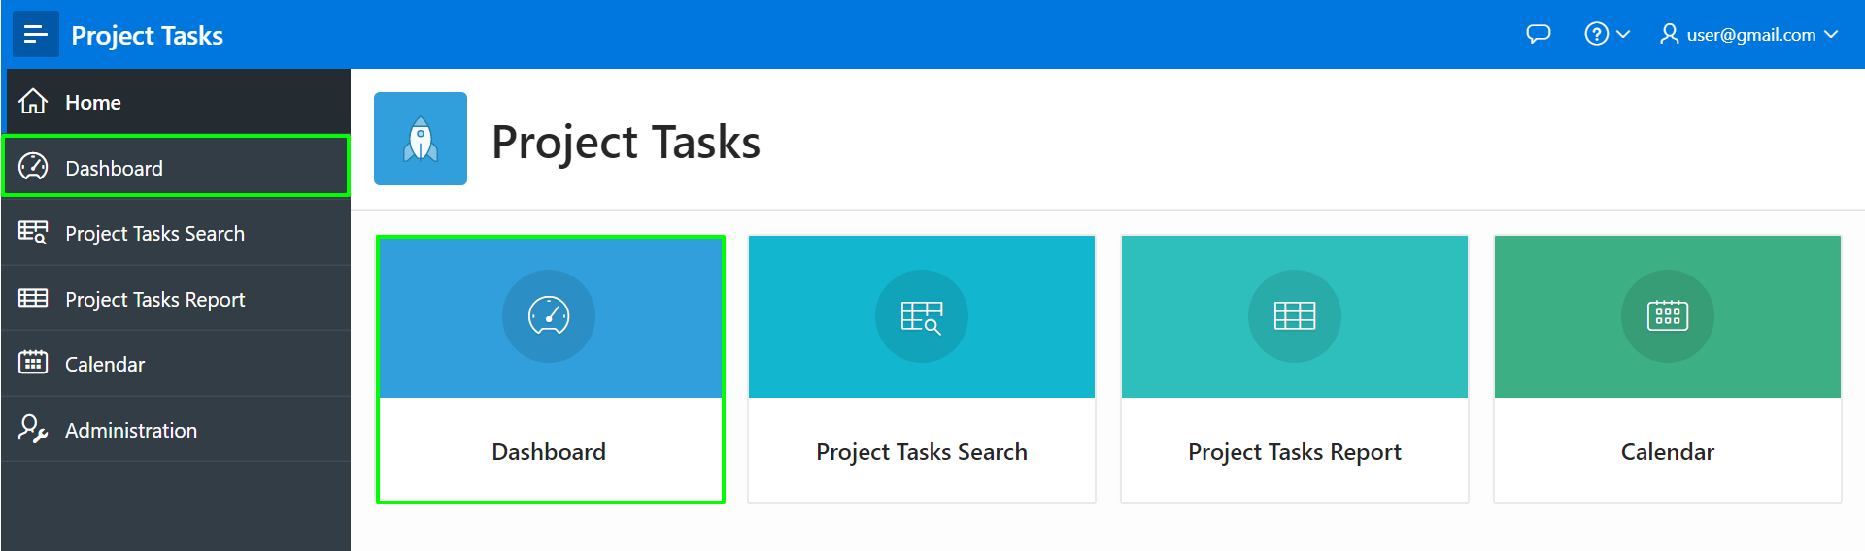

**Summary**

You now know how to create an application from a spreadsheet by either dragging and dropping a file or loading sample data for training purposes.

# Build Database Objects in Autonomous Database

## Introduction

Memorizing the SQL to create and maintain database objects can be difficult. However, there are tools that can generate the code for you based on a shorthand syntax or a graphical user interface. In this lab, you will create database objects using Quick SQL and then view the objects in Database Actions. Then you will then use Database Actions to create an additional table and view all the database objects as a data model.

Estimated Time: 45 minutes

### Objectives

* Create database objects using Quick SQL
* View database objects in Database Actions
* View database objects as a data model
* Create a new table and add it to the data model

### Problem Definition

Within most organizations, the use of spreadsheets is prolific. Spreadsheets are excellent for doing simple data review and tracking personal data. However, they are ill suited to gathering data among team members.

A common use case is when a manager needs to track different projects his team is working on. The manager built a spreadsheet with the critical data elements. However, now that the team is growing, trying to manage the spreadsheet updates is becoming unmanageable, and it is near impossible to get a single source of truth.

Below is an excerpt from the spreadsheet the manager has been sending out to the team:

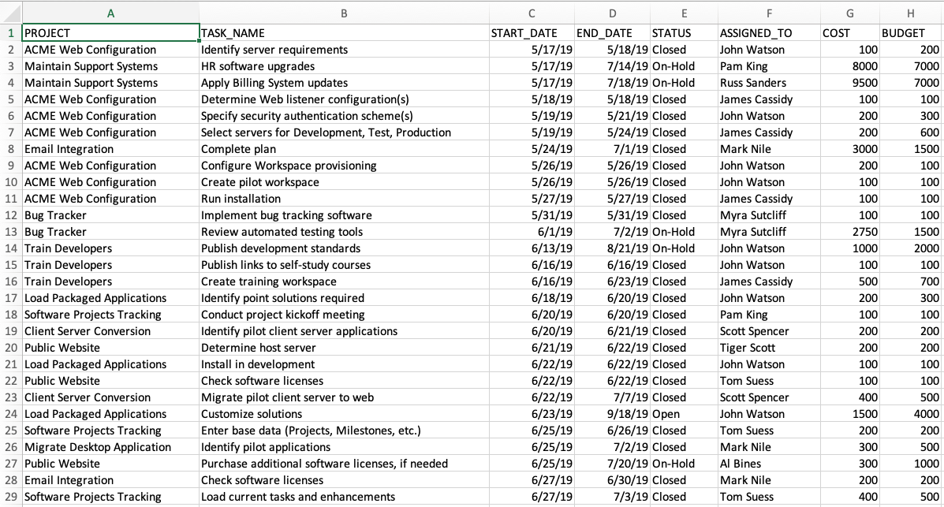

### Napkin Design - Improved data model for Projects

Rather than creating a single Project Tasks table based on the spreadsheet, as you did in the previous lab, you can define a collection of data structures to better model the relationships, and collect additional information that would be valuable.

Below is a napkin design for collecting project information:

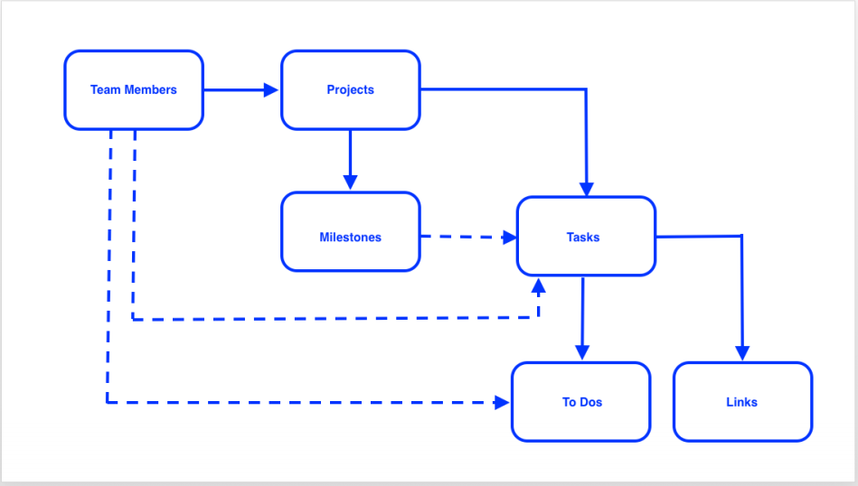

You should notice that the new model allows the assignment of Team Members to Projects, as well as optionally to Tasks, and To Dos. The concept of a Project having Milestones has been introduced, however, it is optional that Tasks are associated with a Milestone. Further, To Dos and Links have been added to Tasks.

## Task 1: Create database objects using Quick SQL

1. Return to your APEX Workspace and click the **SQL Workshop** tab, then click **SQL Scripts**.

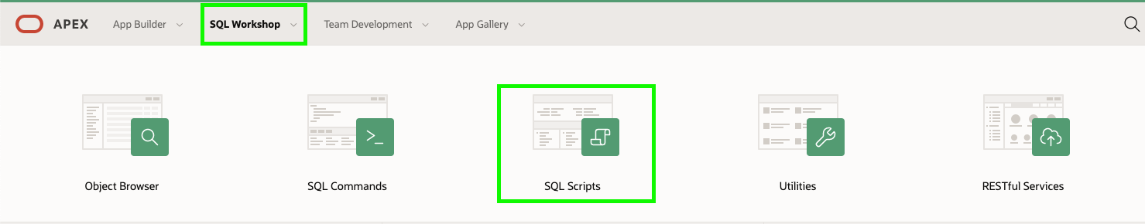

1. Quick SQL is a tool for creating database objects and data using a SQL shorthand syntax.

In the SQL Scripts toolbar, click **Quick SQL**.

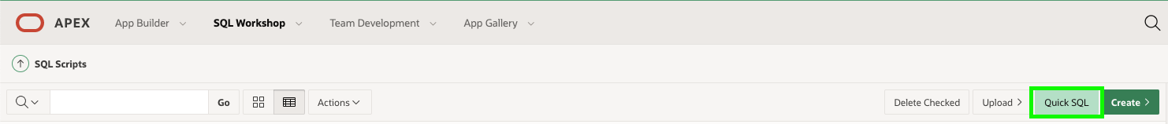

1. Copy the following SQL shorthand code and paste it into the left pane in Quick SQL.
2. team_members /insert 10
3. username /nn /upper
4. full name
5. email /nn
6. phone_number
7. profile
8. photo file
9. projects /insert 20
10. name /nn
11. project_lead /nn /references team_members
12. budget num
13. status vc30 /nn /check ASSIGNED, IN-PROGRESS, COMPLETED
14. completed_date
15. description
16. milestones /insert 30
17. name /nn
18. due_date /nn
19. description
20. tasks /insert 100
21. name /nn
22. assignee /nn /references team_members
23. milestone_id /references milestones
24. start_date /nn
25. end_date
26. cost num
27. description
28. is_complete_yn /check Y, N
29. view project_tasks projects tasks

Note: This shorthand does not include the To DOs and Links tables from the napkin design. You will add the To Dos table using Database Actions later in this lab.

1. Review the shorthand code. How many tables will be created and how are they related? What types of columns and constraints will be created for the tables? Note that the **Help** button provides details on the shorthand syntax along with several examples of its usage.

When ready, in the Quick SQL (left pane) toolbar, click **Generate SQL**.

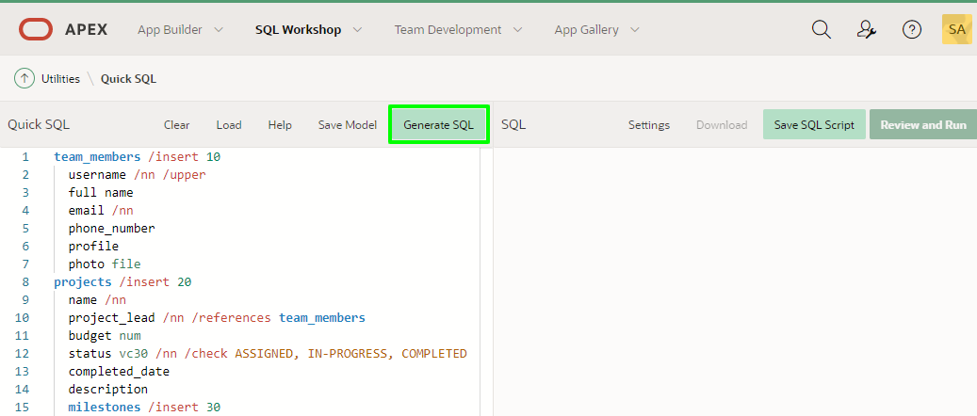

1. Review the SQL that is generated in the right-hand pane, then click **Settings** to make some changes to the resulting code.

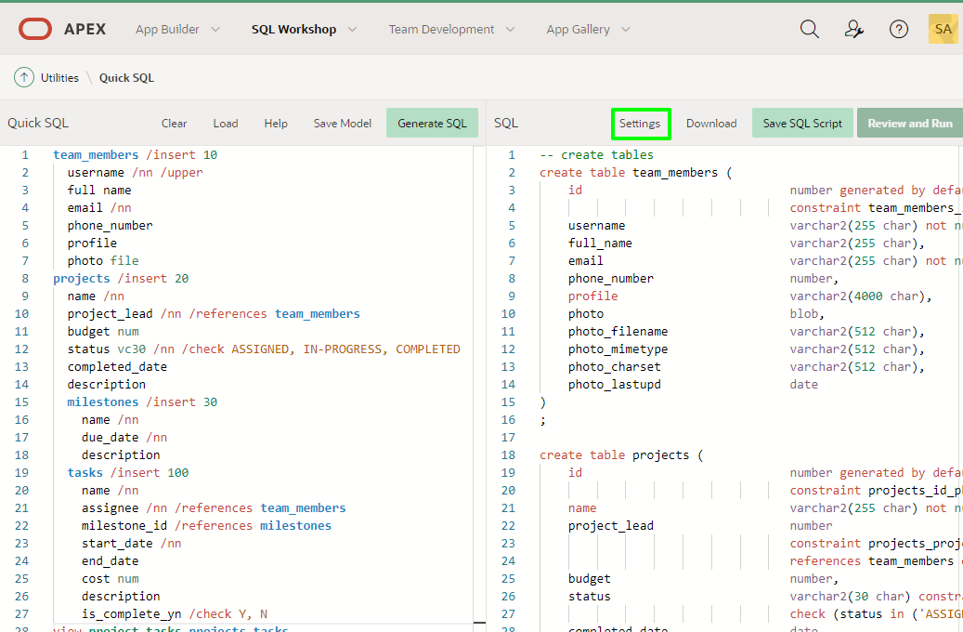

1. Change the following settings and click **Save Changes**.

| **Property** | **Value** |
| --- | --- |
| Object Prefix | **HOL** |
| On Delete | **Restrict** |
| Primary Keys | **12c Identity Data Types** |
| Date Data Type | **TIMESTAMP WITH LOCAL TIME ZONE** |
| Include | Select **Audit Columns** & **Row Version Number** |

1. 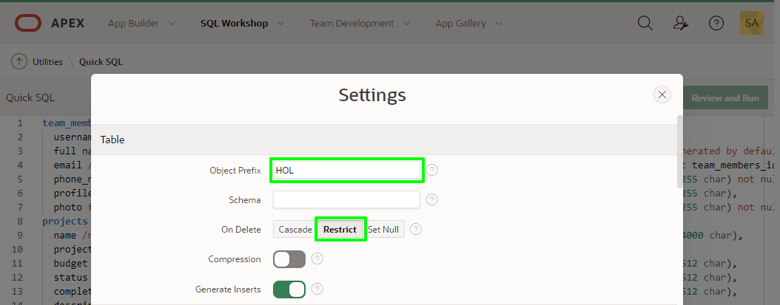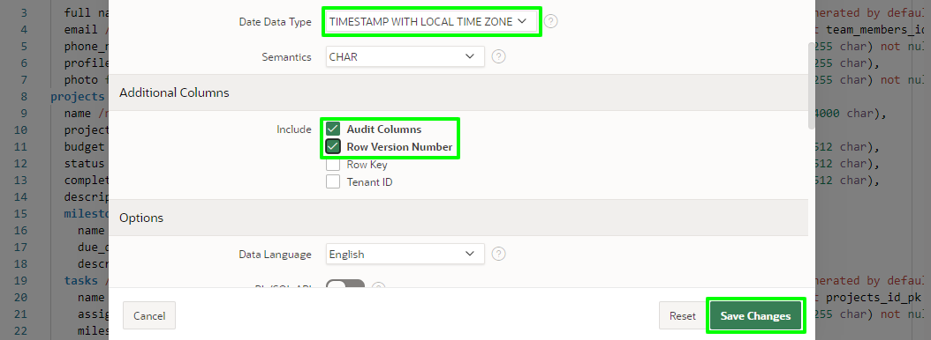
2. After clicking **Save Changes** the SQL will be regenerated taking the new settings into account.
3. It is important to save the SQL Shorthand as a script so that it can be run in your database.

In the SQL (right pane) toolbar, click **Save SQL Script**.  
In the Save Script dialog, for Script Name enter **HOL**, and click **Save Script**.

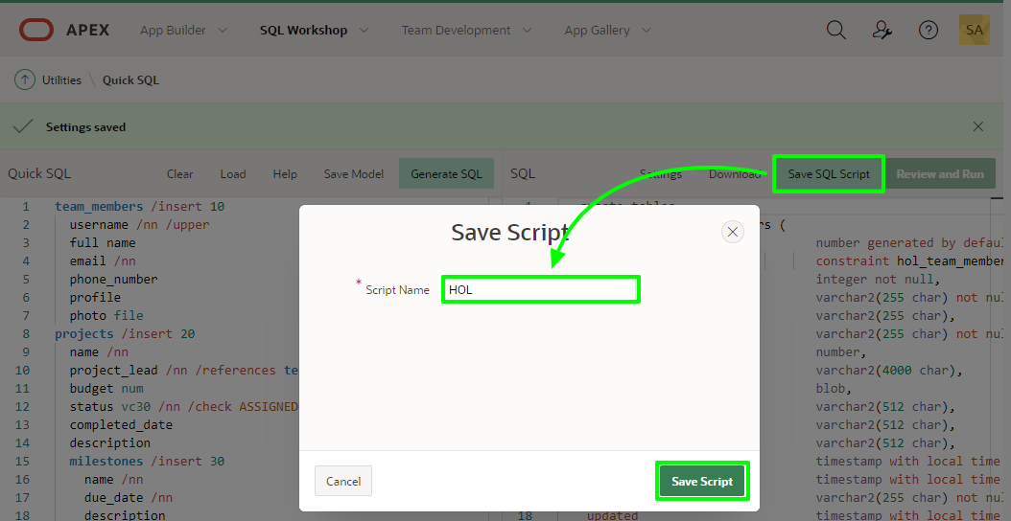

1. Now that you saved the script you can run it to create the specified database objects.

In the SQL (right pane) toolbar, click **Review and Run**.

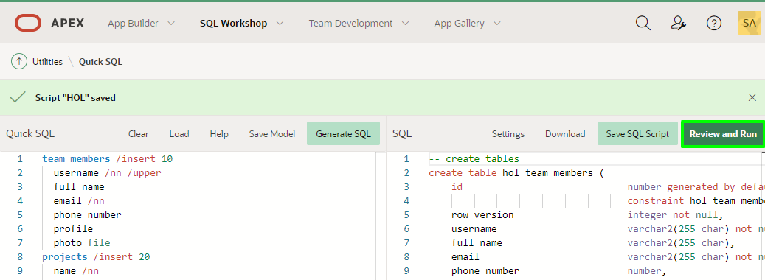

1. In the Script Editor page toolbar, click **Run**.

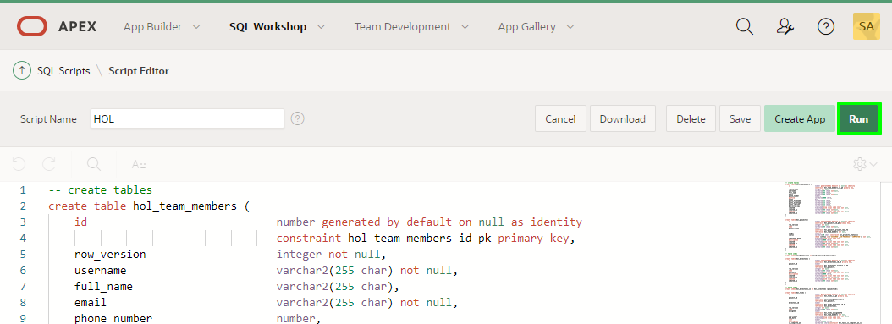

1. On the Run Script page, click **Run Now**.

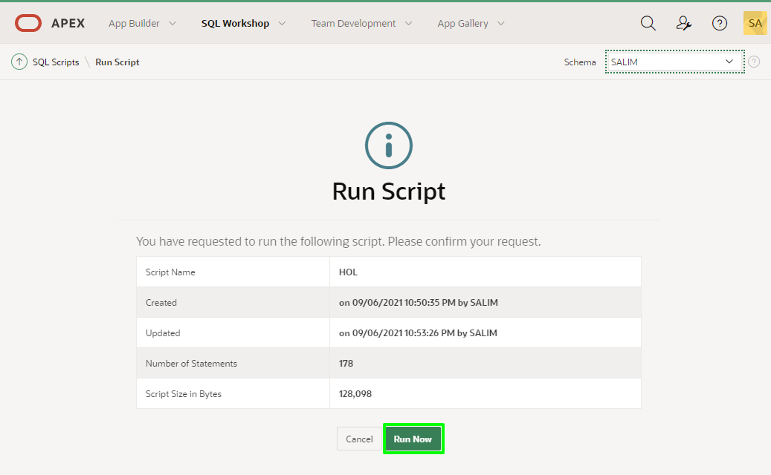

1. The Results page shows the results of running the script. Scroll to the bottom to see a summary. You should not see any errors.

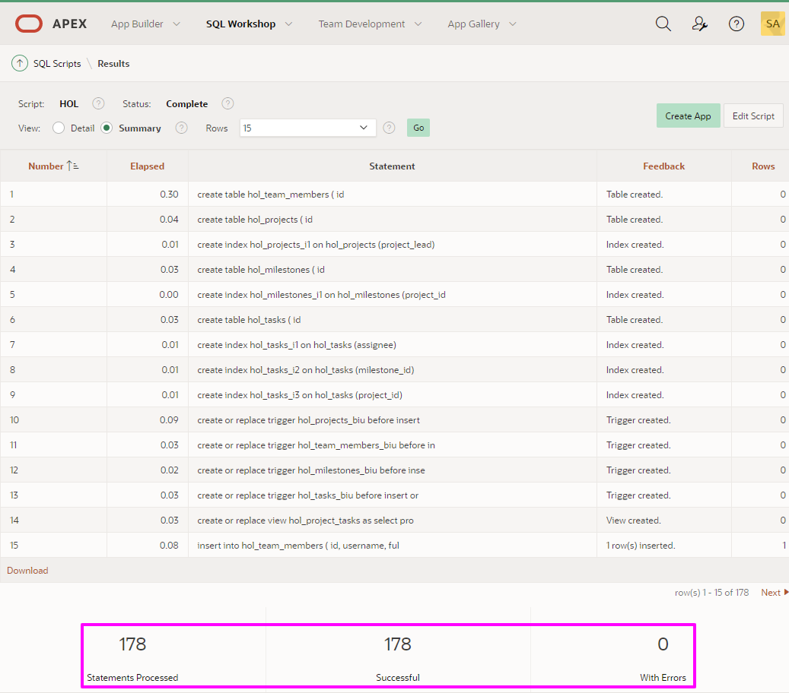

1. To view the database objects that were created, click the arrow in the **SQL Workshop** tab and then select **Object Browser**.

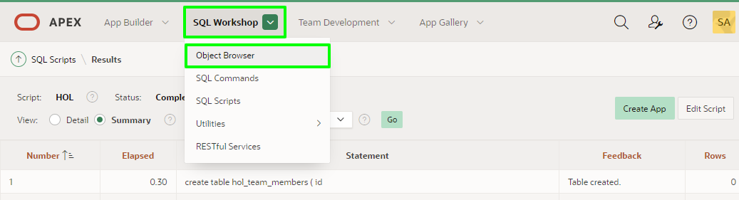

1. Select the **HOL_PROJECTS** table and review its columns.

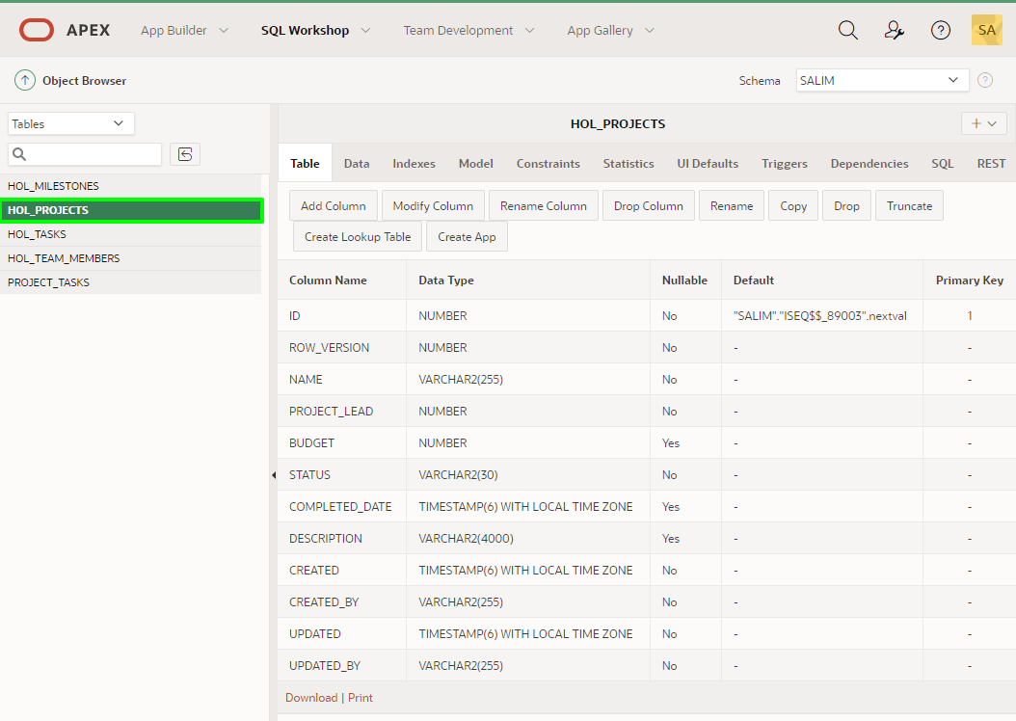

1. Click the **Data** tab to see the data that was loaded.

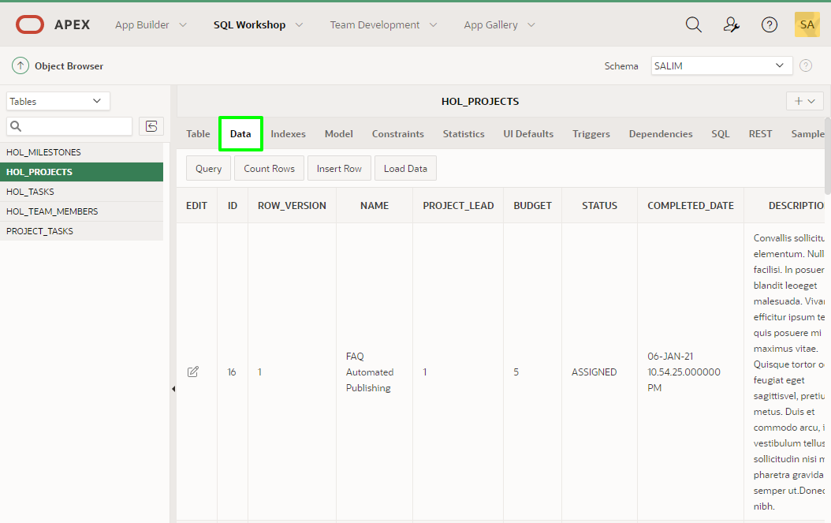

## Task 2: View database objects in Database Actions

In this step, you will learn how to access Database Actions and then use it to review the current database objects and make some modifications to the data model.

1. Switch to the ATP Console in your browser. It should still be displaying the **Tools** tab.

Within the Tools tab, click **Open Database Actions**.

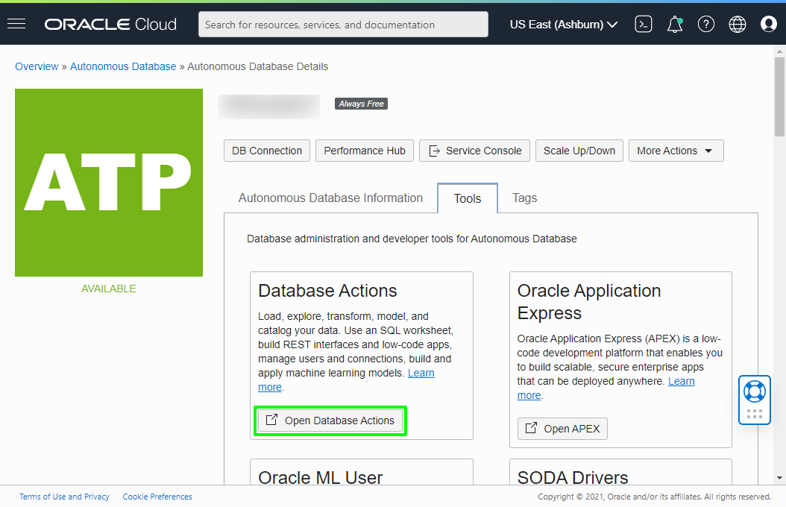

1. On the Database Actions log-in page, for Username enter **admin** and for Password enter **SecretPassw0rd**, and then click **Sign In**.

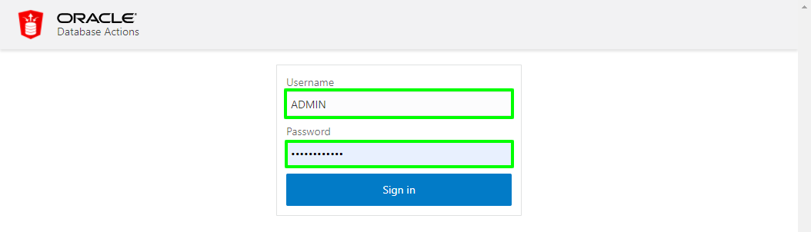

Under **Development**, click the **SQL** menu item

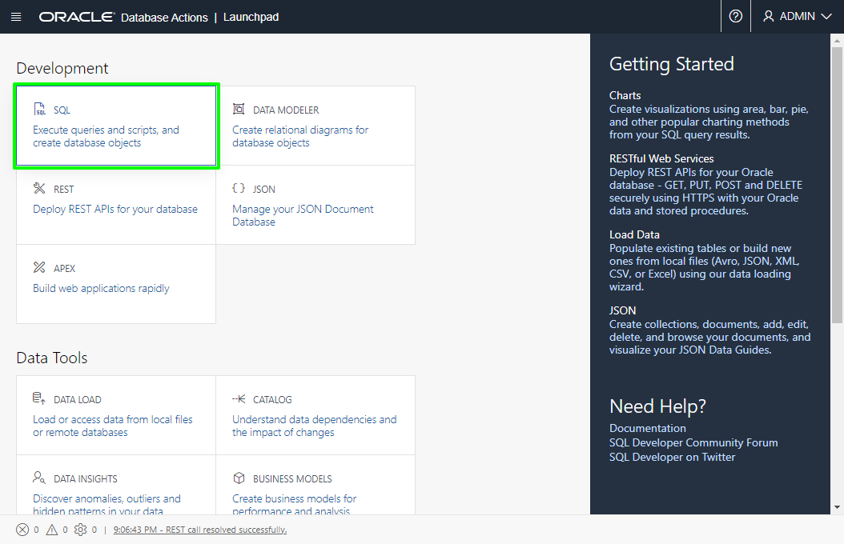

1. You created your database objects in the DEMO schema so you will need to enable Database Actions access for that schema. Close the help popup, then copy and paste the following code into the Worksheet.

• begin

ords_admin.enable_schema(

p_enabled => true,

p_schema => 'DEMO', -- Actual name of the schema

p_url_mapping_type => 'BASE_PATH',

p_url_mapping_pattern => 'demorest', -- Alias used in the URL for access

p_auto_rest_auth => true

);

commit;

end;

• In the Worksheet toolbar, click **Run Script** to execute the code in the Worksheet. When the script finishes executing, you should see a success message under the **Script Output** tab at the bottom.

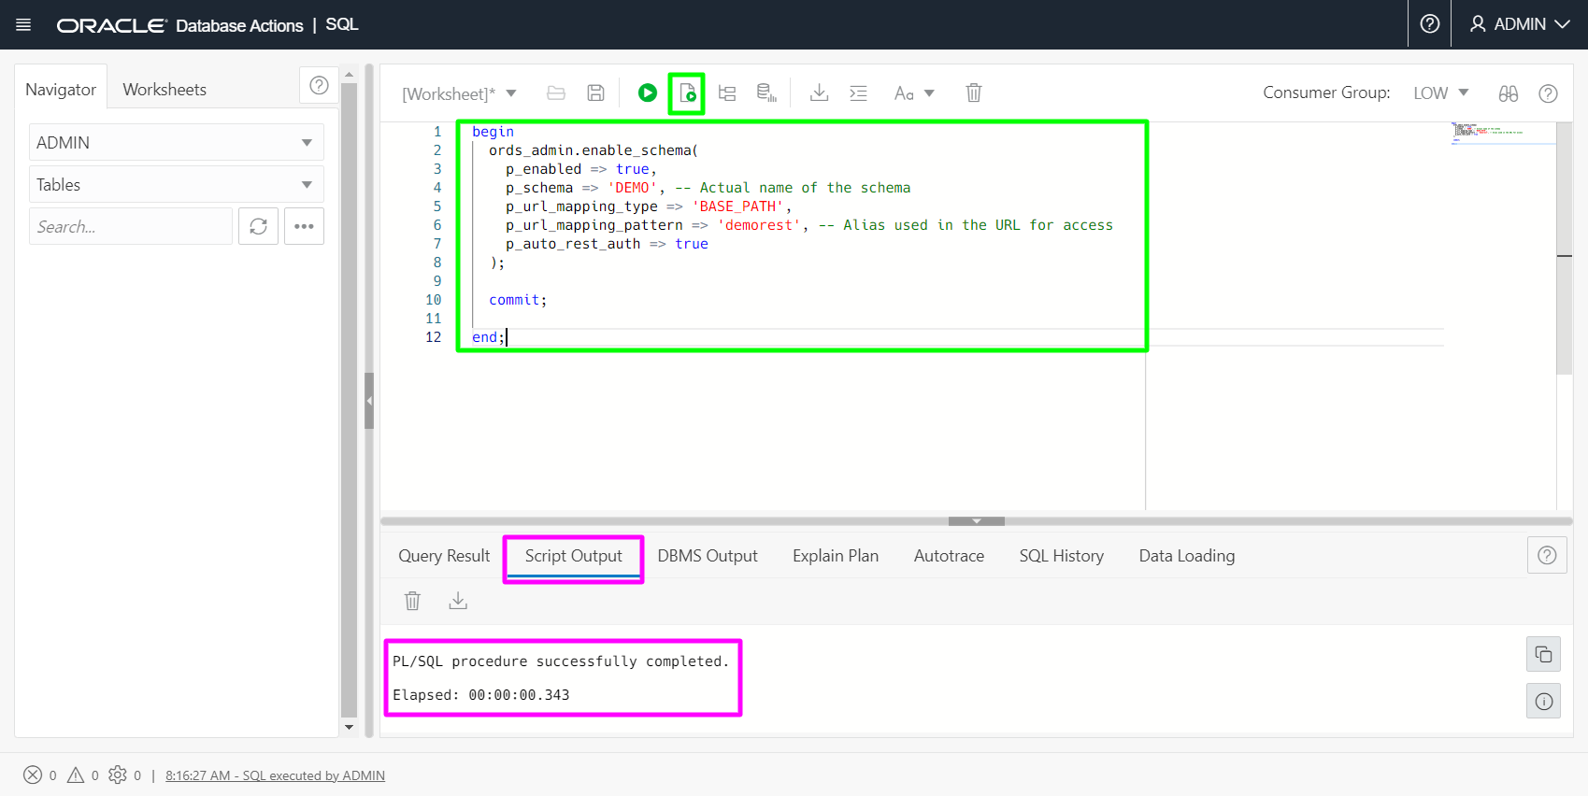

• In the browser address bar, change the URL by replacing admin with demo (the value passed to the p_url_mapping_pattern parameter in the script above). Then press enter to go to the new URL.

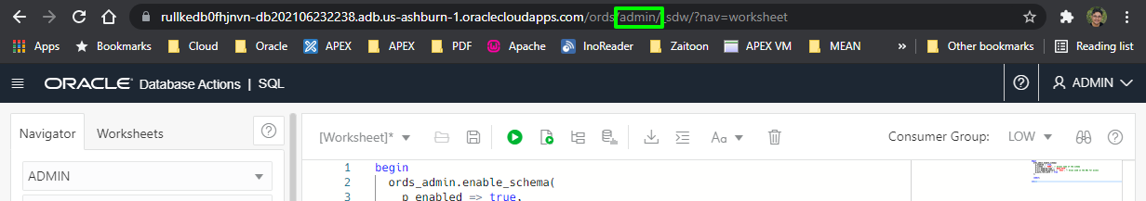

• In the SQL Developer log-in page, set Username to **demo** and Password to **SecretPassw0rd**, then click **Sign In**.

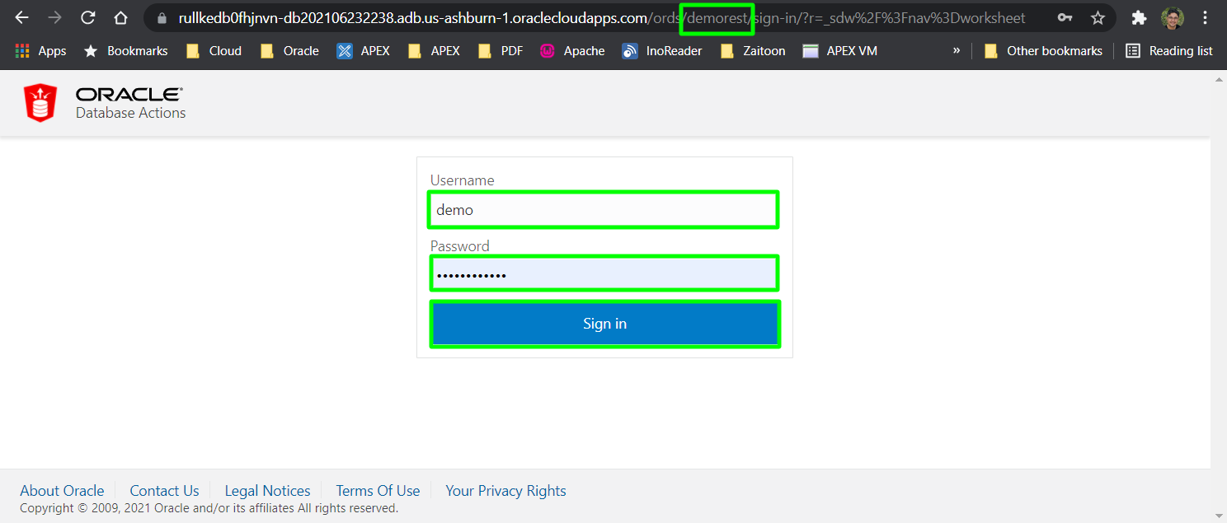

Under **Development**, click the **SQL** menu item

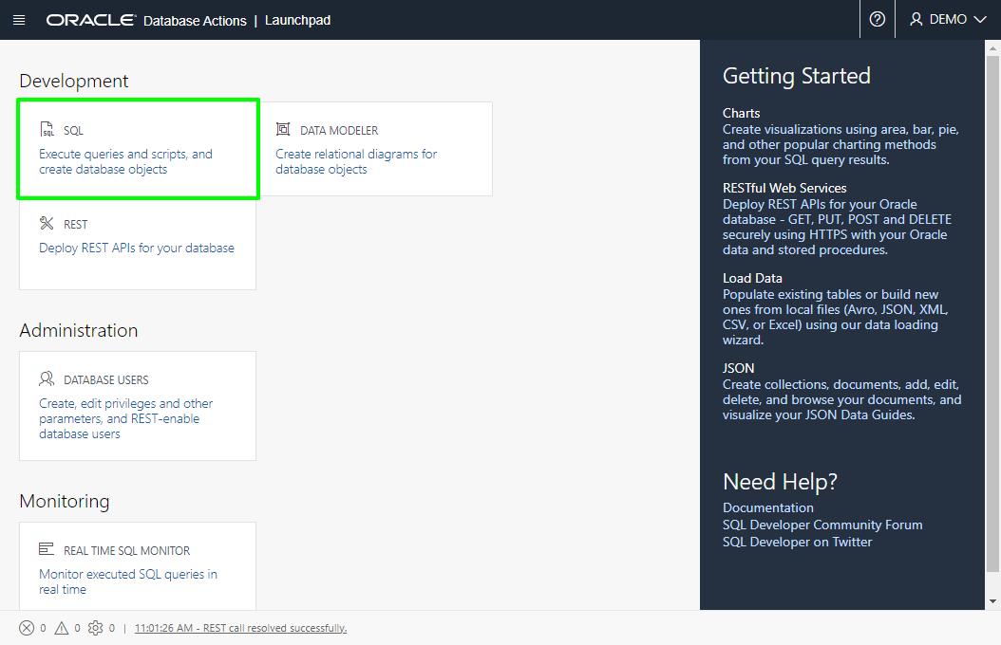

• The Worksheet tab is displayed by default. Close the help popup and look under the **Navigator** tab to see the tables you created previously.

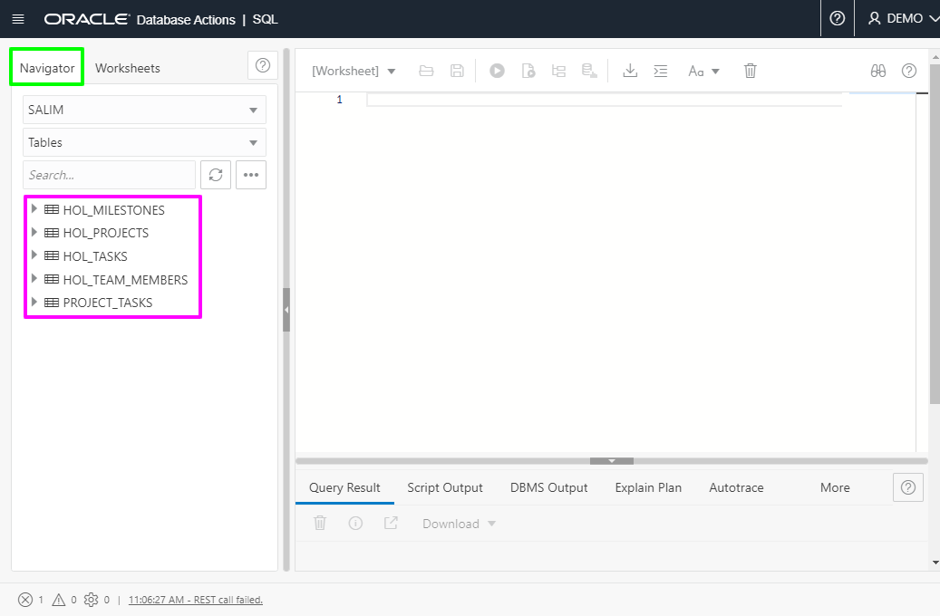

• Expand the **HOL_PROJECTS** table to see the columns.

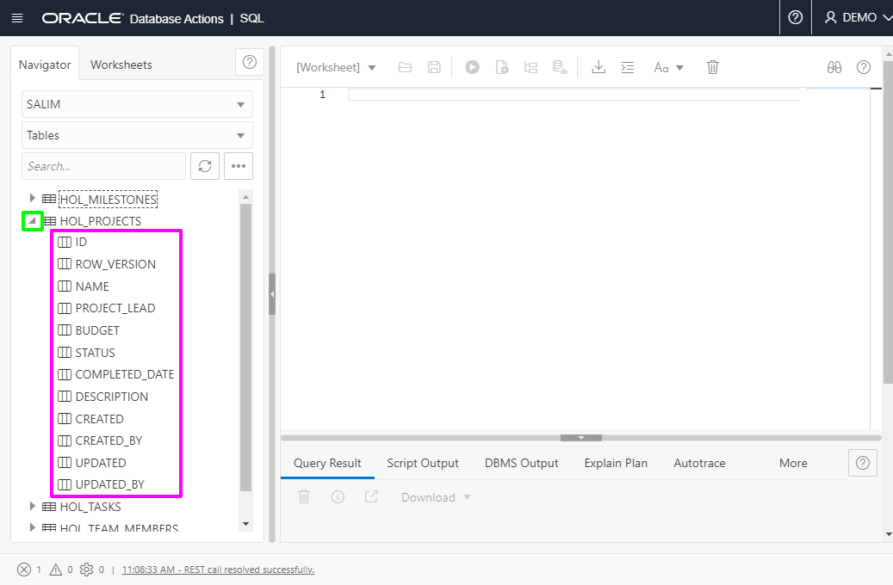

• In the Worksheet (right pane), cut and paste the following SQL query:

1. select * from hol_projects;

In the Worksheet toolbar, click **Run Script** to see the data in the table. The data should be displayed in the Script Output tab at the bottom. Note: The table you see may contain different values.

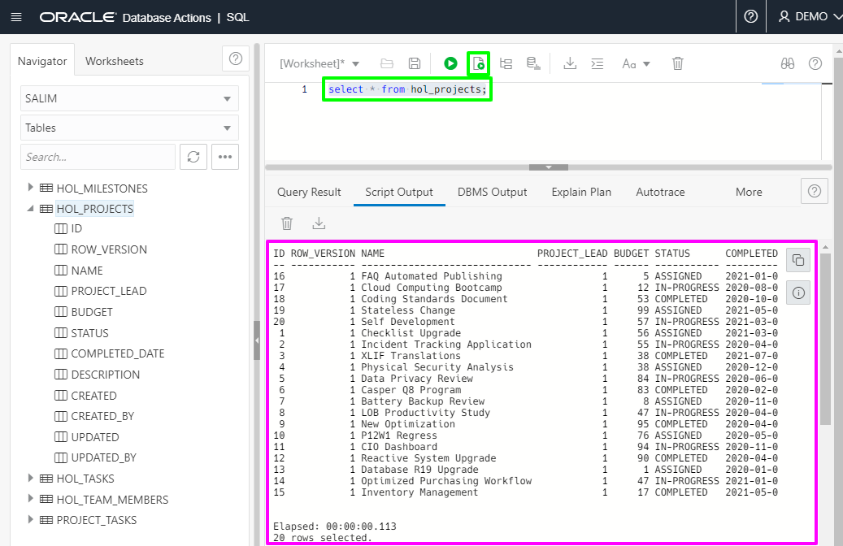

## Task 3: View database objects as a data model

In this step, you will learn how to create an Entity Relationship Diagram (ERD) using Database Actions.

1. Click the top left icon then click on **Data Modeler** link.

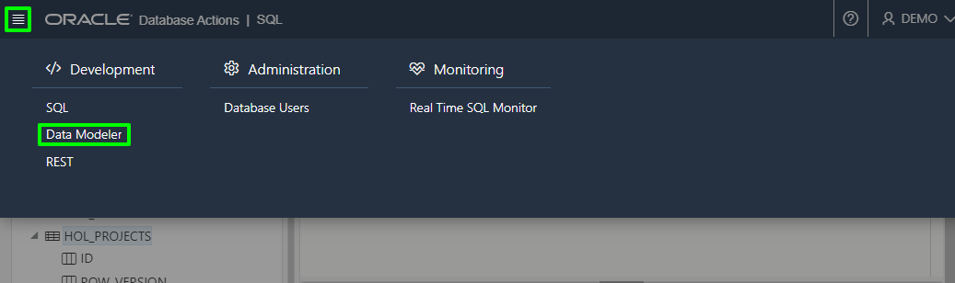

1. Drag the **HOL_MILESTONES** table from the Navigator tab on the left to the diagram in the middle of the window. You may need to adjust your browser to accommodate the ERD.

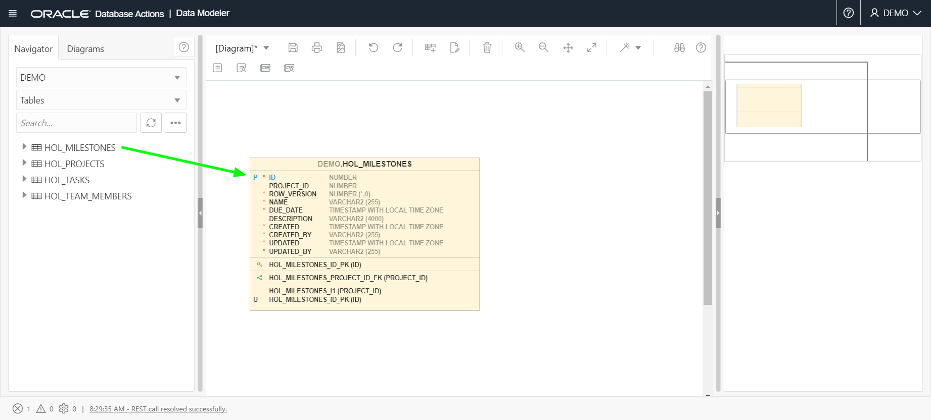

1. Drag the other three **HOL_** tables to the right. Use the diagram controls to adjust the zoom level and layout of the objects. Note that the foreign keys are detected and drawn on the diagram.

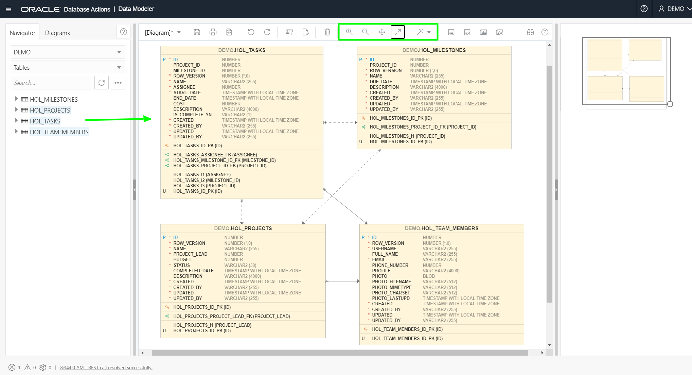

1. Click the **HOL_PROJECTS** table in the diagram. Note that the detail is displayed in the right navigator.

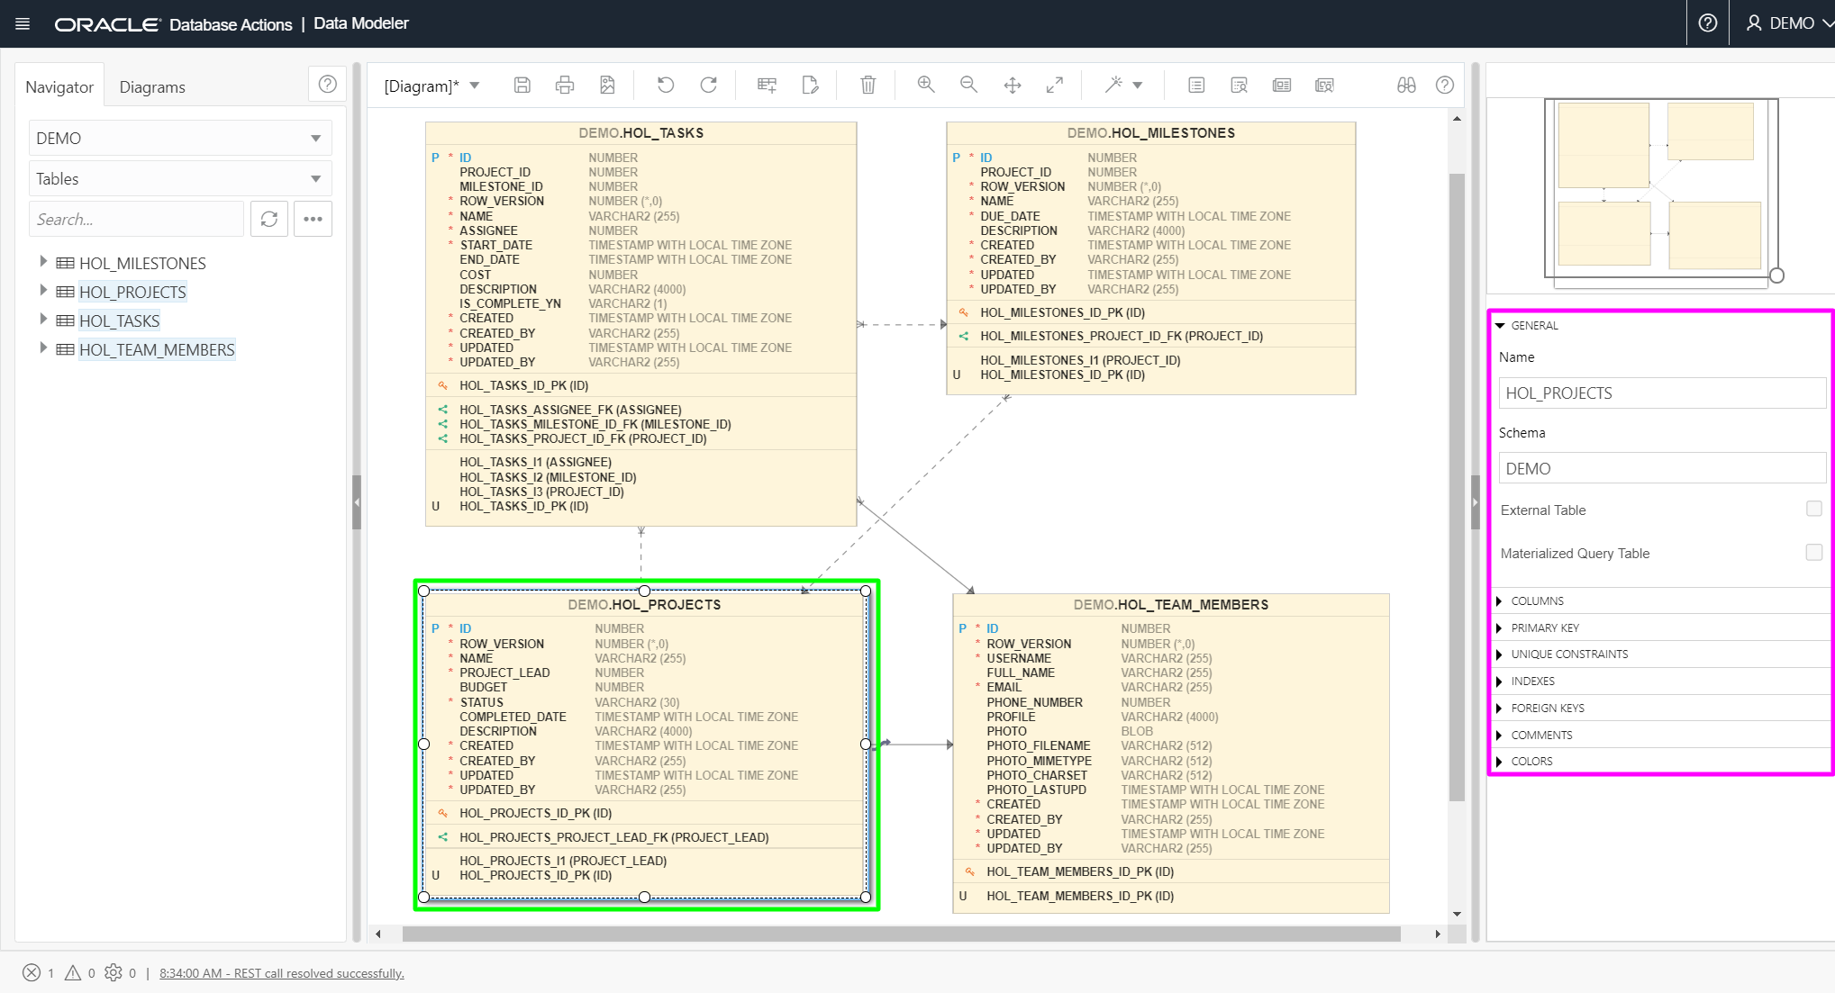

## Task 4: Create a new table and add it to the data model

In this step, you will use Database Actions to create a new table. Then you will learn how to edit an existing table and add it to the ERD created in the previous step.

In the original napkin design, there was a table called To Dos. However, the Quick SQL script (used in step 1) did not include this table. Below you will recreate the TO Dos table with a relationship to Team Members, and Tasks.

1. In the Navigator (left pane), click the **…** button and select **Create Object**.

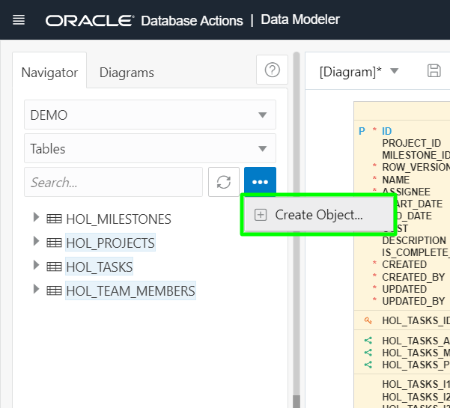

1. In the Table Properties dialog, enter **HOL_TODOS** in the Name field. and click "**+**" to create a new column.

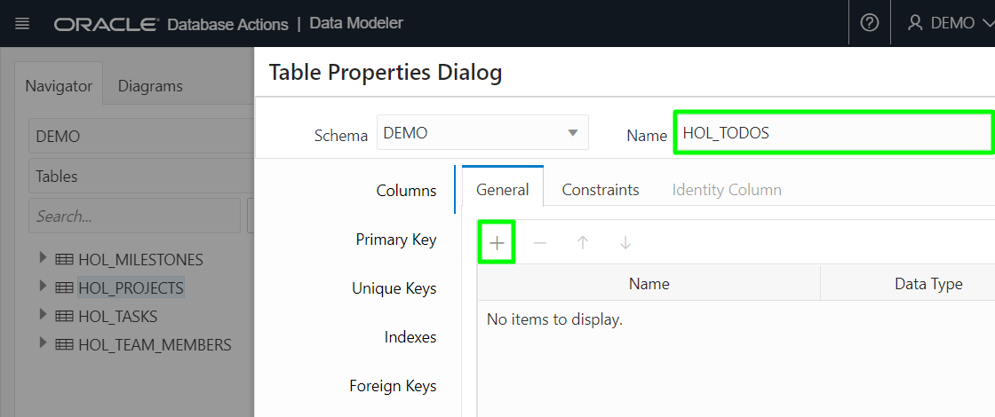

1. Select the new column **NEW_COLUMN_1** and select the checkbox for **PK** to make it the primary key for this new table. Click in the Name field and enter **ID**. Click in the Data Type and select **NUMBER** from the drop down list.

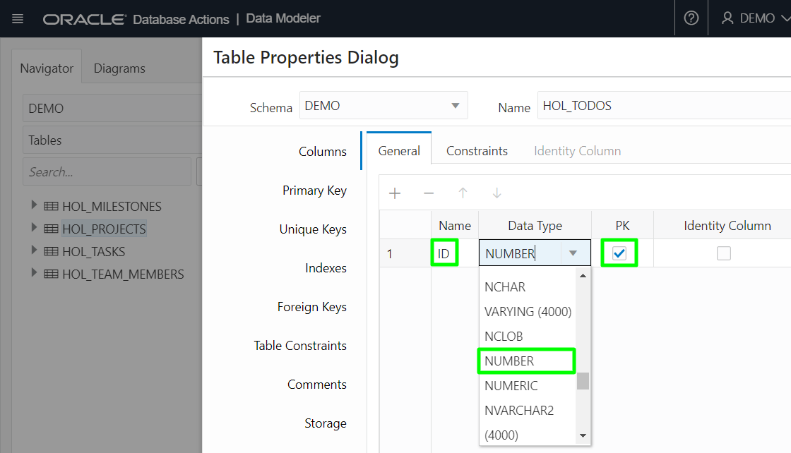

1. Press "**+**" to add three additional columns to the table with the following properties:

| **#** | **Name** | **Data Type** |
| --- | --- | --- |
| 1 | **NAME** | **VARCHAR2(50)**  (just change the number 20 to 50) |
| 2 | **STATUS** | **VARCHAR2(20)** |
| 3 | **DUE_DATE** | **TIMESTAMP WITH LOCAL TIME ZONE**  (just type the full data type name) |

1. Click **Create**.
2. 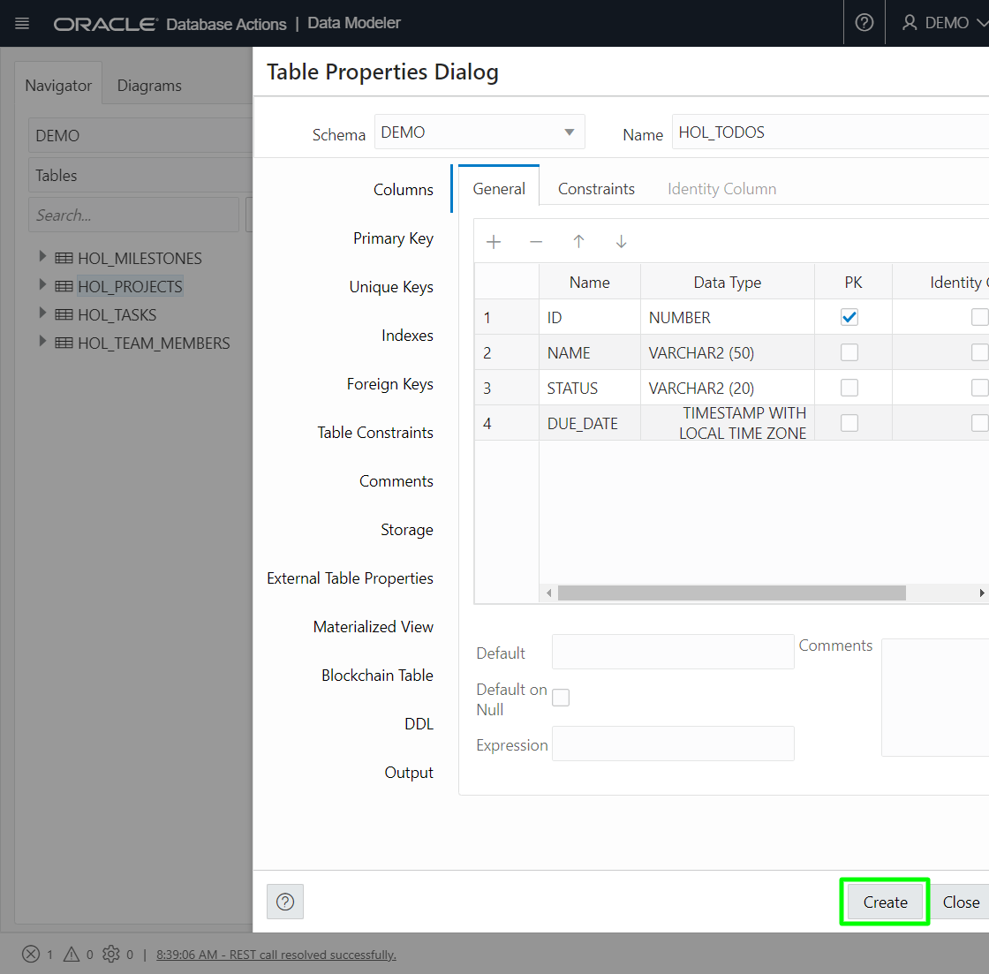
3. This will generate a SQL script and run it to create the table.  
   When ready, click **Close**.

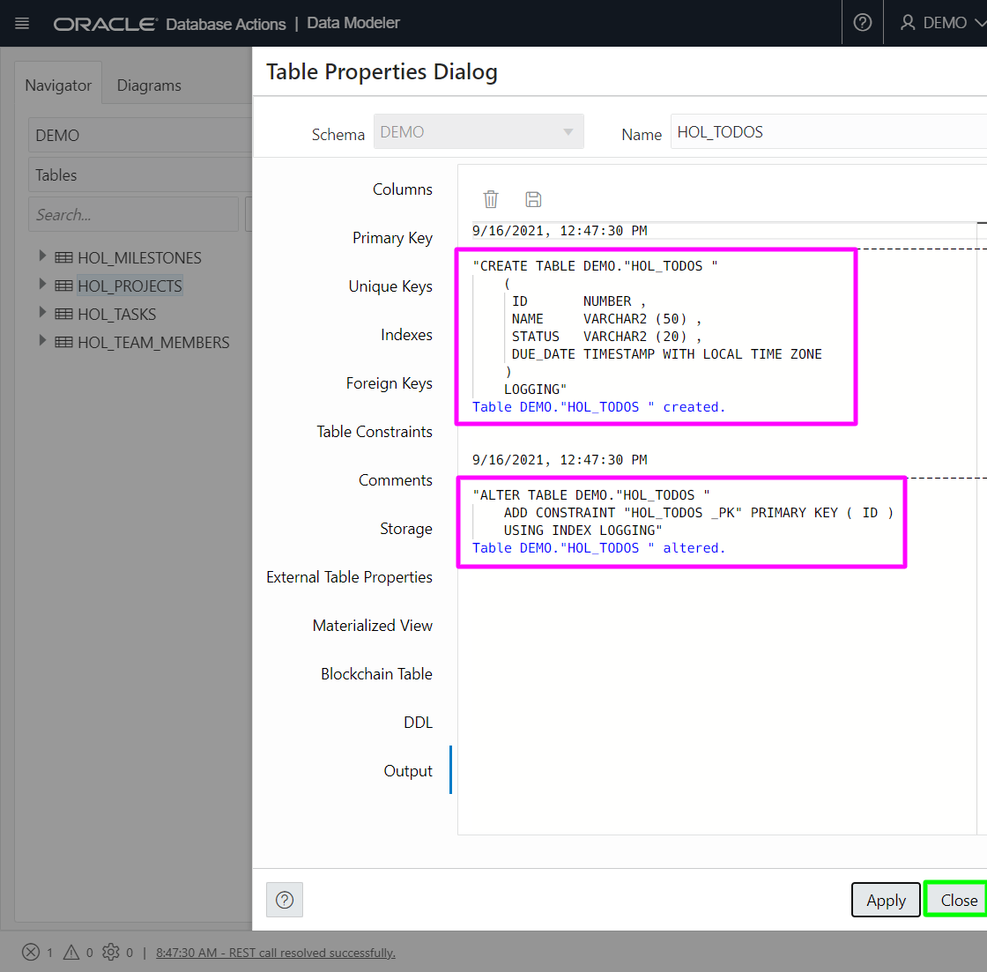

1. In the Navigator, click the Refresh icon to see the new **HOL_TODOS** table.

Right-click on the **HOL_TODOS** table and select **Edit…**.

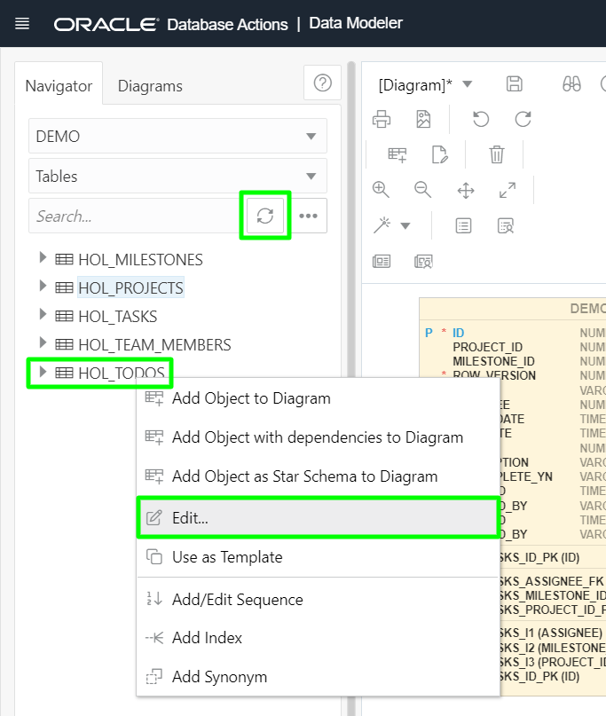

1. Add a new column.  
   Set Name to **TEAM_MEMBER_ID** and Data Type to **NUMBER**, then click **Apply**.

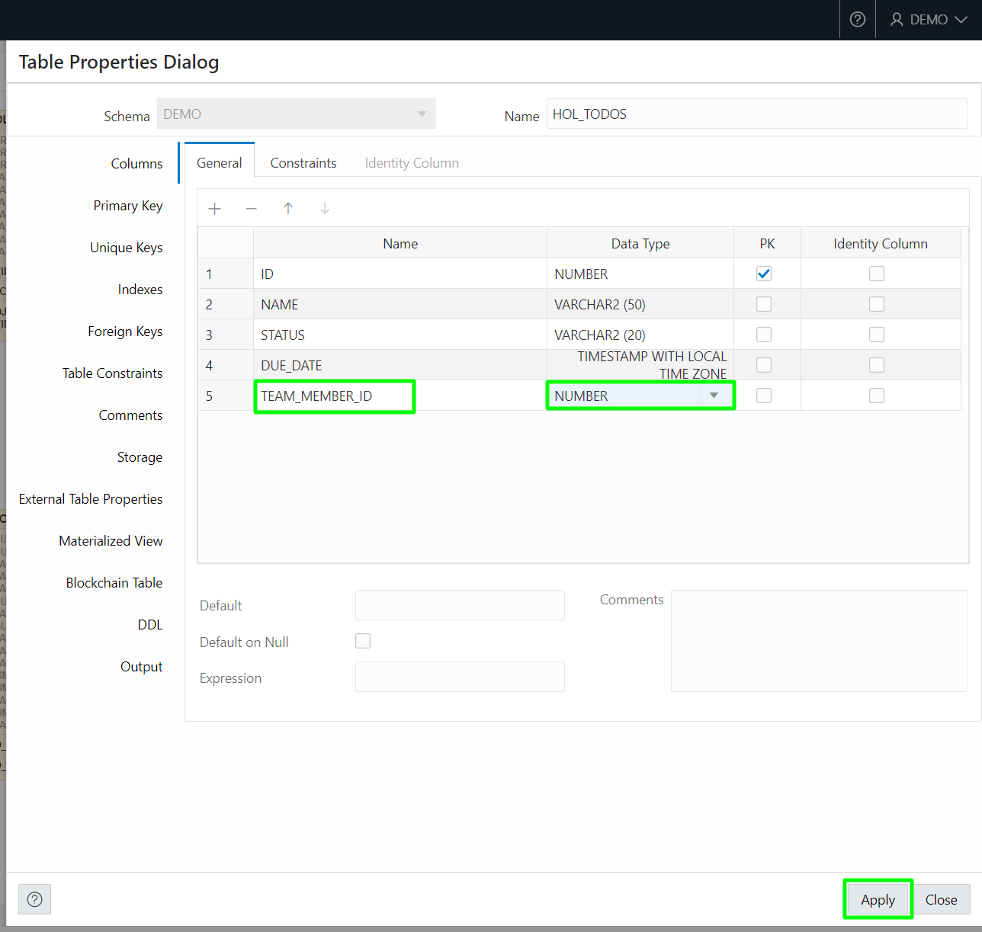

You should see the following output which indicates the new column was added successfully.

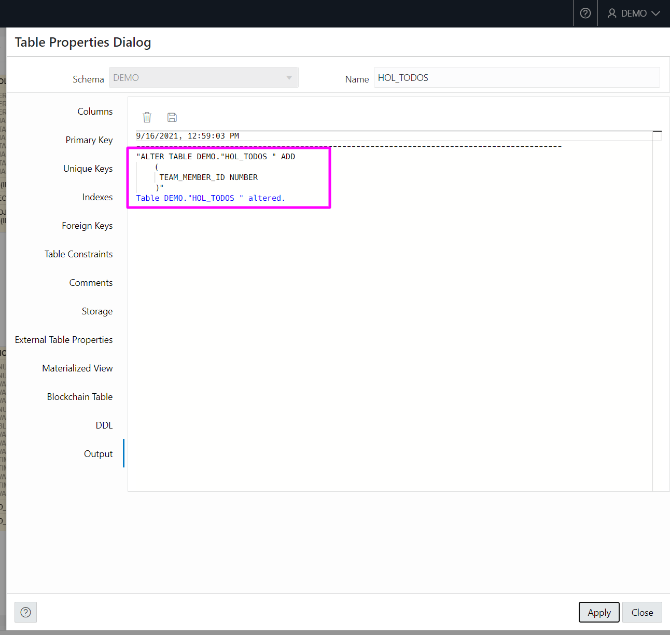

1. Click the **Foreign Key** option on the left side of the dialog, then click "**+**" to create a new foreign key.

Select the new foreign key and configure it with the following settings:

| **Property** | **Value** |
| --- | --- |
| Name | **TODOS_TEAM_MEMBERS_FK** |
| Table | **HOL_TEAM_MEMBERS** |
| Constraint | **HOL_TEAM_MEMBERS_ID_PK** |
| Local Column | **TEAM_MEMBER_ID** |

Note: If when selecting the Local Column, you see NEW_COLUMN_5 instead of TEAM_MEMBER_ID then close the dialog, refresh the Navigator and then edit the table again.

Click **Apply**.

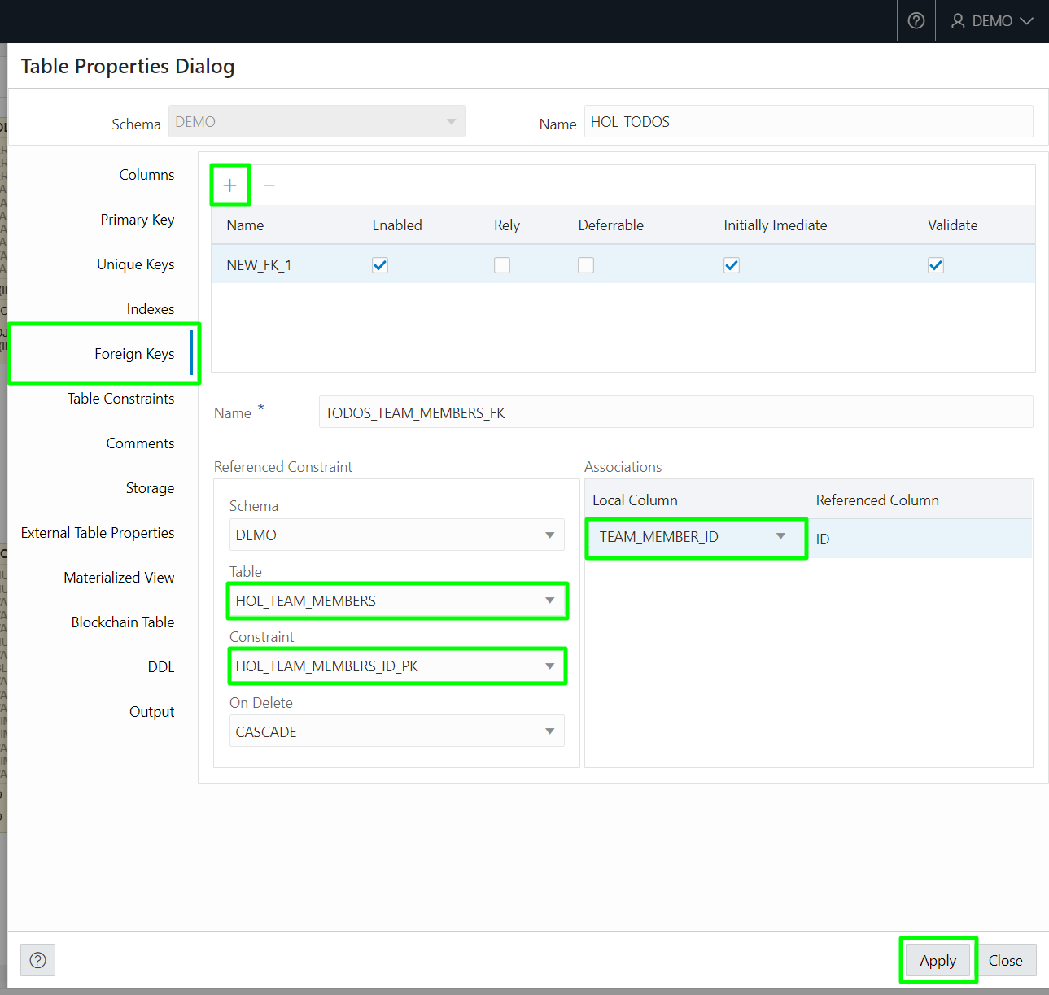

You should see the following output which indicates the new foreign key was added successfully.

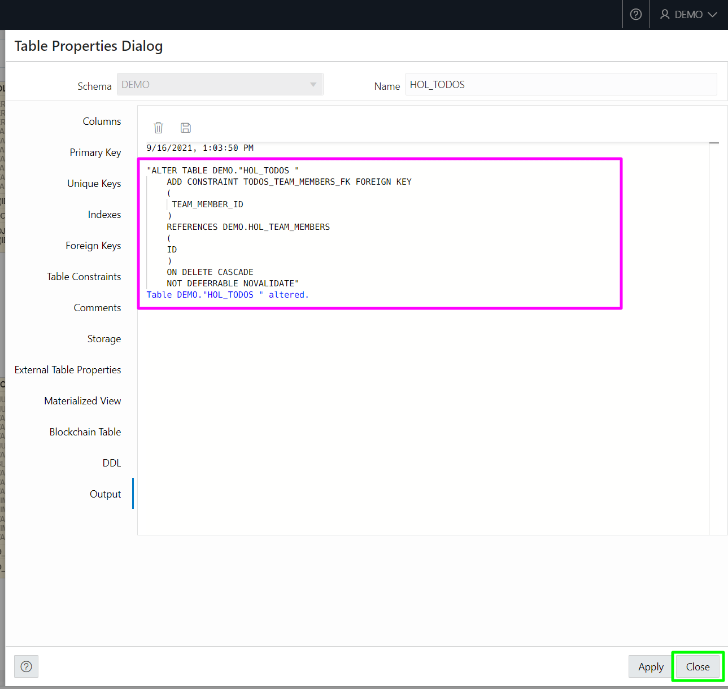

Click **Close** to dismiss the dialog.

1. Repeat the steps above to create a new column to link to the Tasks table.

Right-click on the **HOL_TODOS** table and select **Edit…**.

Click "**+**" to create a new column. Set Name to **TASK_ID** and Data Type to **NUMBER**, then click **Apply**.

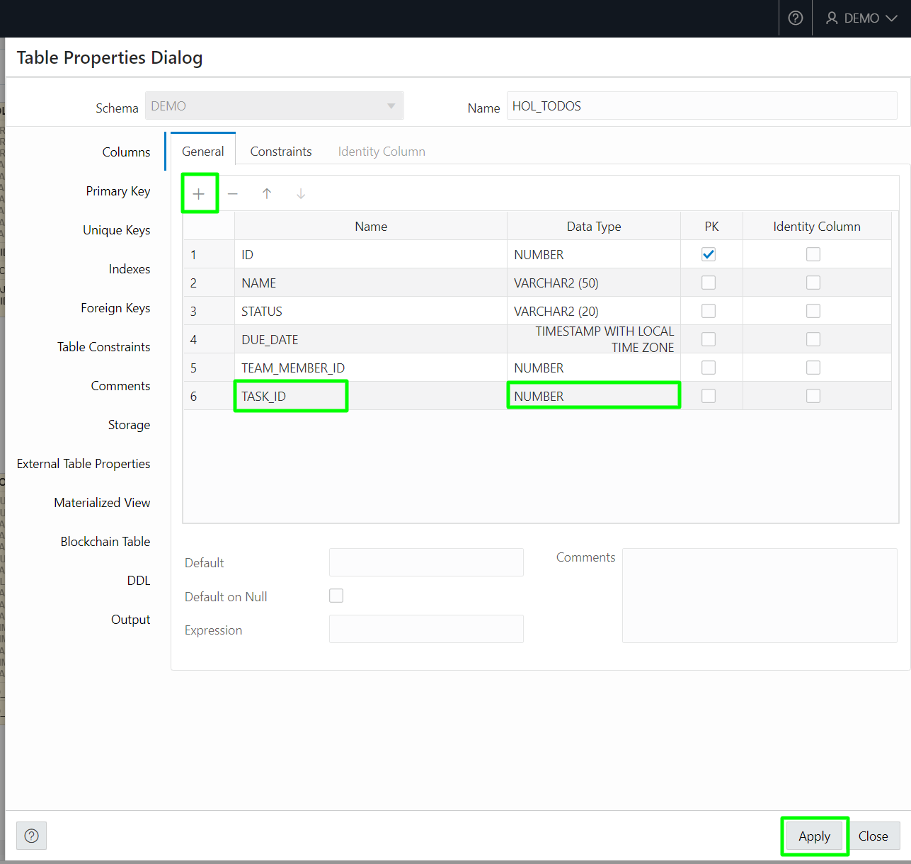

1. Click the **Foreign Key** option on the left side of the dialog, then click "**+**" to create a new foreign key.

Select the new foreign key and configure it with the following settings:

| **Property** | **Value** |
| --- | --- |
| Name | **TODOS_TASKS_FK** |
| Table | **HOL_TASKS** |
| Constraint | **HOL_TASKS_ID_PK** |
| Local Column | **TASK_ID** |

Note: If when selecting the Local Column, you see NEW_COLUMN_6 instead of TASK_ID then close the dialog, refresh the Navigator and then edit the table again.

Click **Apply**.

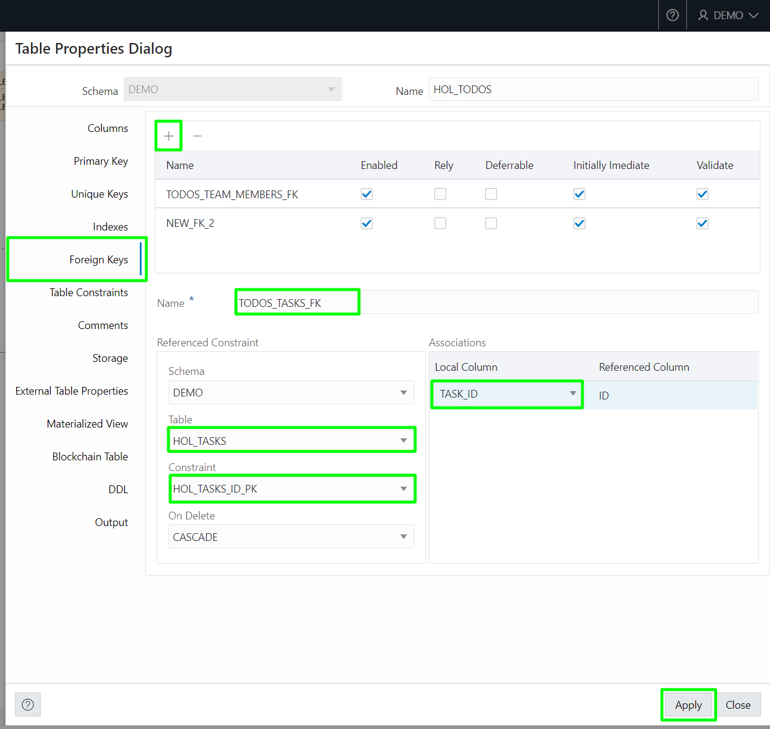

You should see the following output which indicates the new foreign key was added successfully.

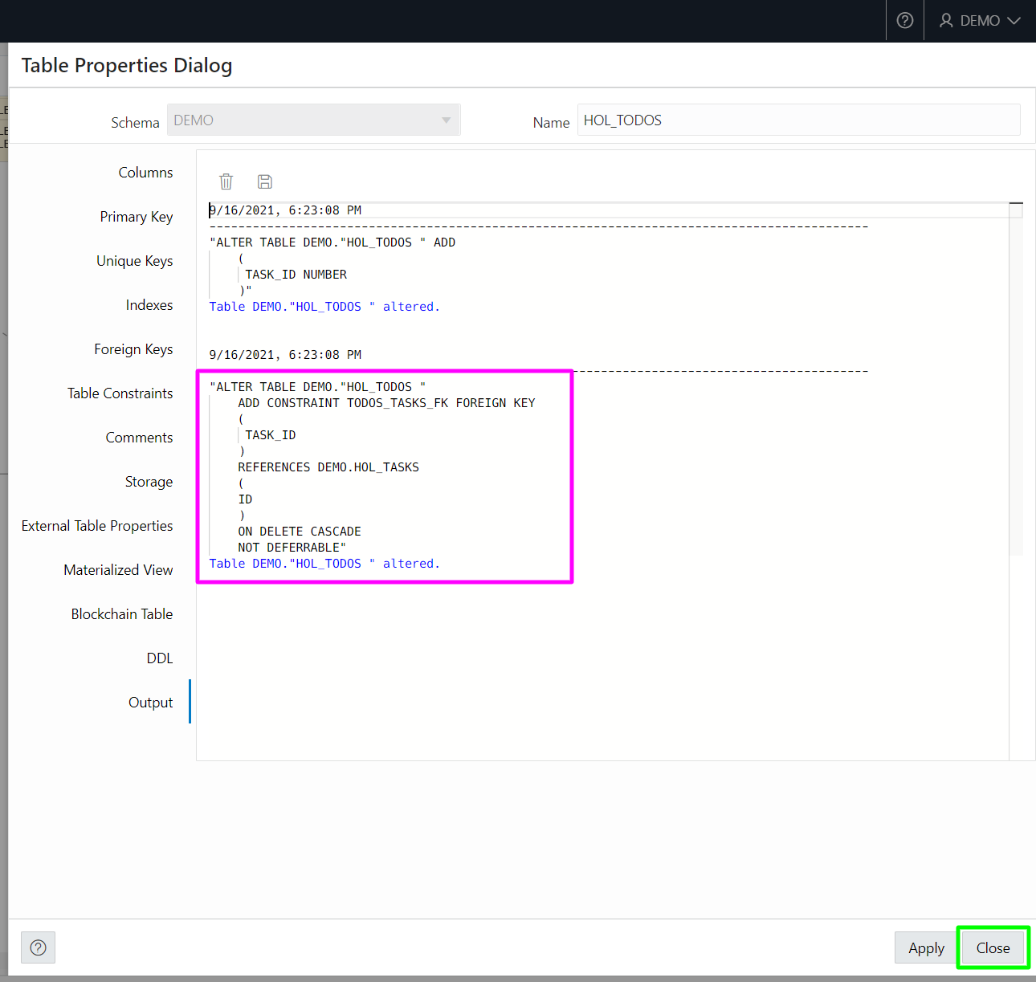

Click **Close** to dismiss the dialog.

1. Drag the new **HOL_TODOS** table from the Navigator to the diagram. Notice that the new foreign keys are displayed from **HOL_TODOS** to **HOL_TEAM_MEMBERS** and **HOL_TASKS**.

Rearrange the diagram to clearly display the tables and their foreign key relationships.

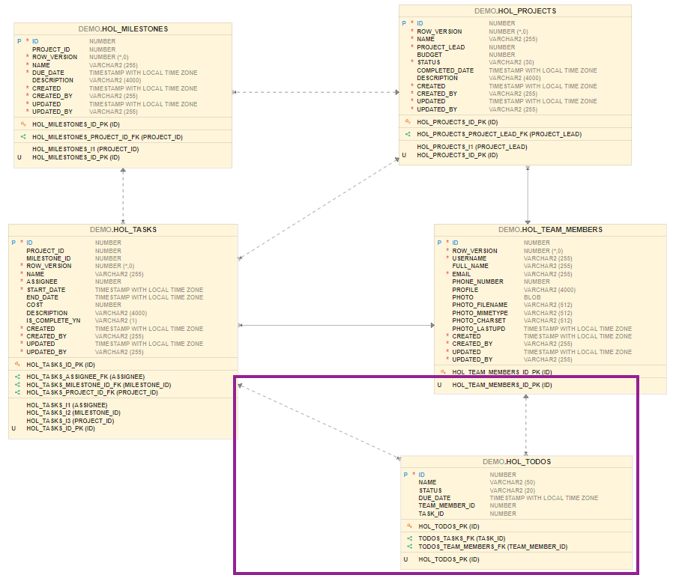

## Summary

This completes this workshop. At this point you know how to use Quick SQL to generate database objects using a SQL shorthand. You also know how to use Database Actions to maintain database objects and generate ERDs. Click on **Lab 3: Create and Modify an APEX Application** to create a new APEX application that will utilize the database objects you created.

# Create and Modify an APEX Application

## Introduction

In this lab, you will create a new APEX application that will utilize the database objects you created in the previous module. You will then extend the application by adding an Interactive Grid and Calendar pages.

Estimated Time: 20 minutes

### Objectives

* Create an app from a script
* Add an Interactive Grid page and create records
* Enhance the Interactive Grid
* Add a Calendar page

## Task 1: Create an app from a script

In lab 3, step 1, you used Quick SQL to create a script which you subsequently ran to create several tables. The script's Results page has a button that allows you to create a new application based on the script. APEX will parse the script to identify the tables and then create pages in the new app to view and edit data within those tables. In this part, you will create an app based on the script you previously ran.

1. Return to your APEX Workspace. You may need to re-authenticate if your previous session expired. If you need the APEX URL, return to Oracle Cloud, with the Autonomous Database selected, under the Tools tab, click **Open APEX**. To log in, enter **DEMO** for the Workspace and Username fields and **SecretPassw0rd** for the password, then click **Sign In**.

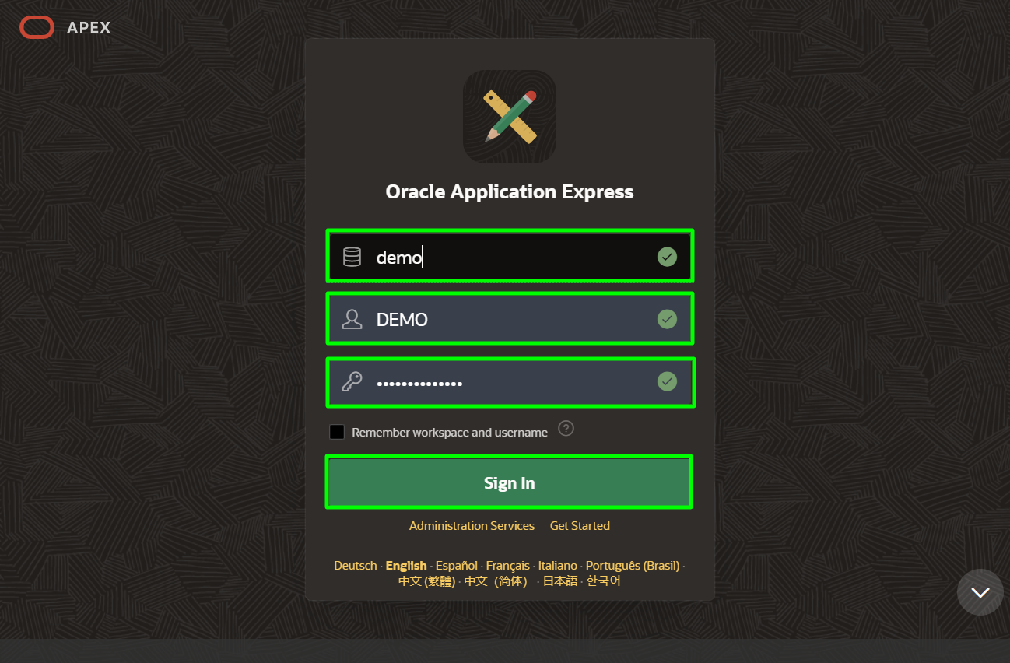

1. Click the down arrow in the **SQL Workshop** tab, then select **SQL Scripts**.

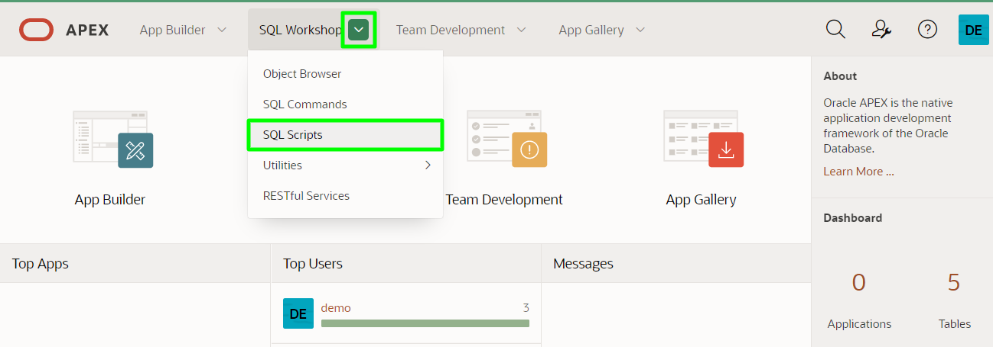

1. Click the number link in the Results column to view the results of the previous runs of the script.

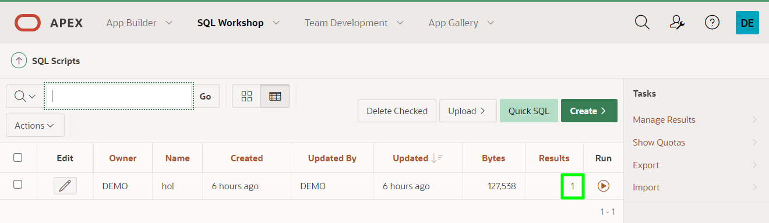

1. Click the magnifying glass icon in the View Results column.

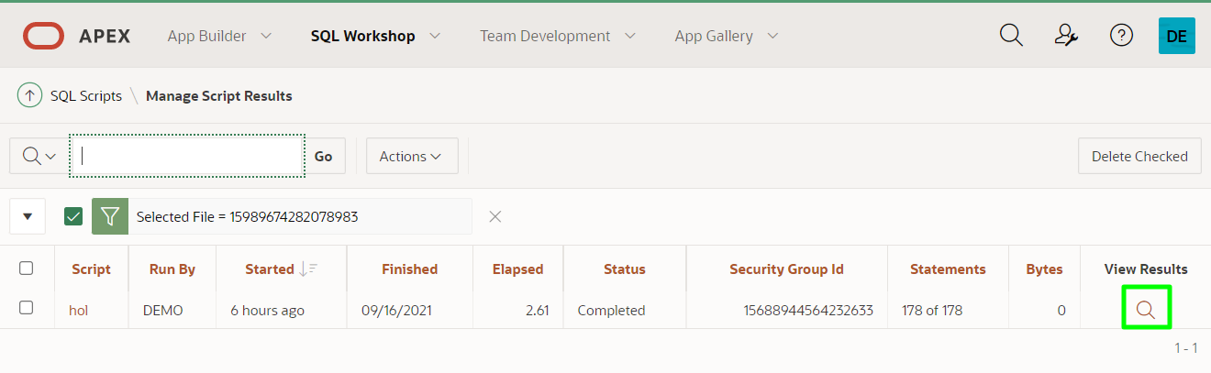

1. On the Results page, click **Create App**.

In the Create App from Script dialog, click **Create Application**.

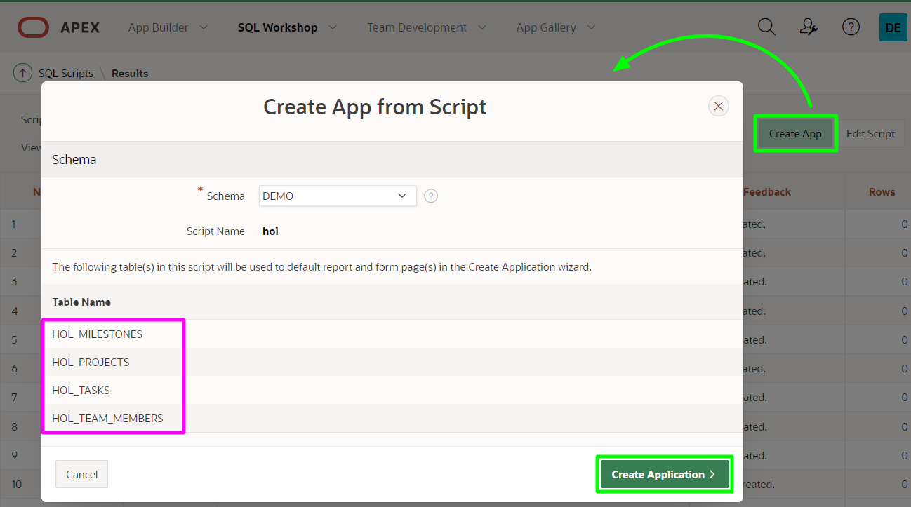

Note: The tables listed are those from the HOL script you created from Quick SQL, and does not include HOL_TODOS which you created manually using SQL Developer Web.

1. On the Create an Application page, set Name to **HOL Projects** and then click **Check All** for Features, and then click **Create Application**.

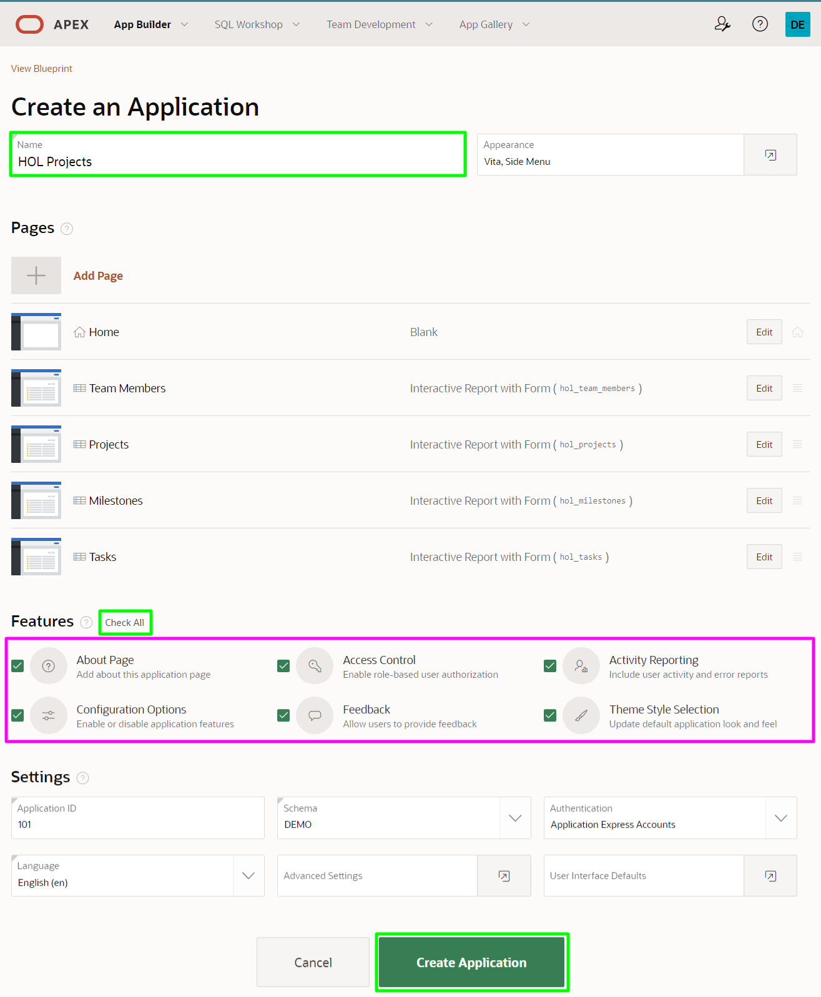

After the app is created, you will be redirected to the application home page in the Application Builder.

1. Click **Run Application** to see the app at runtime.

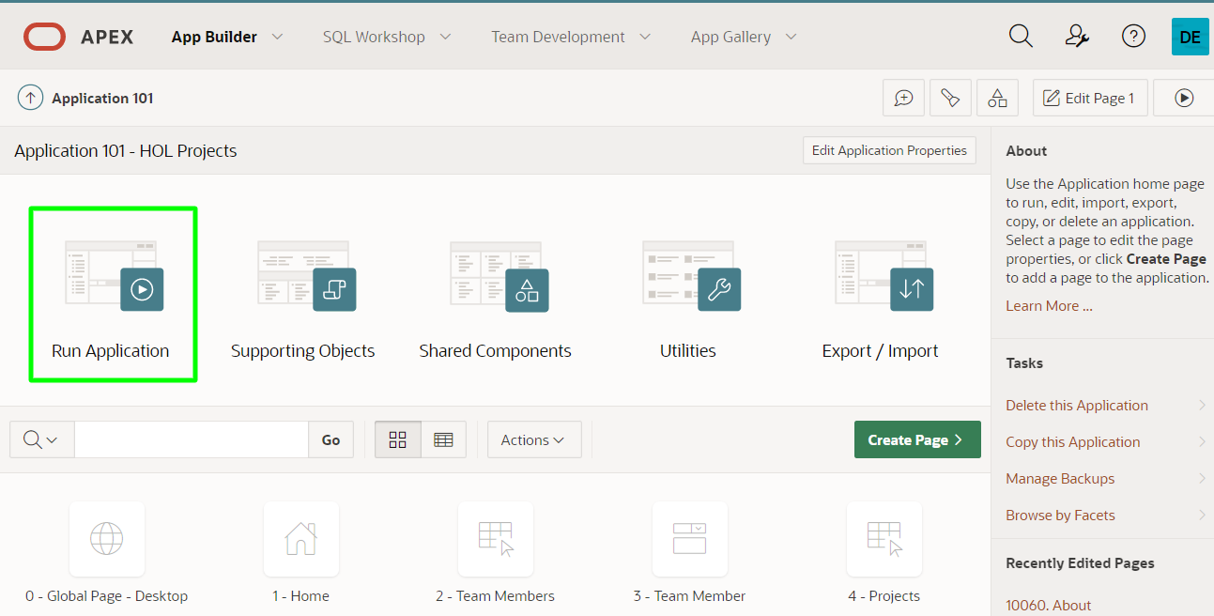

1. Set username to **demo** and password to **SecretPassw0rd**, then click **Sign In**.

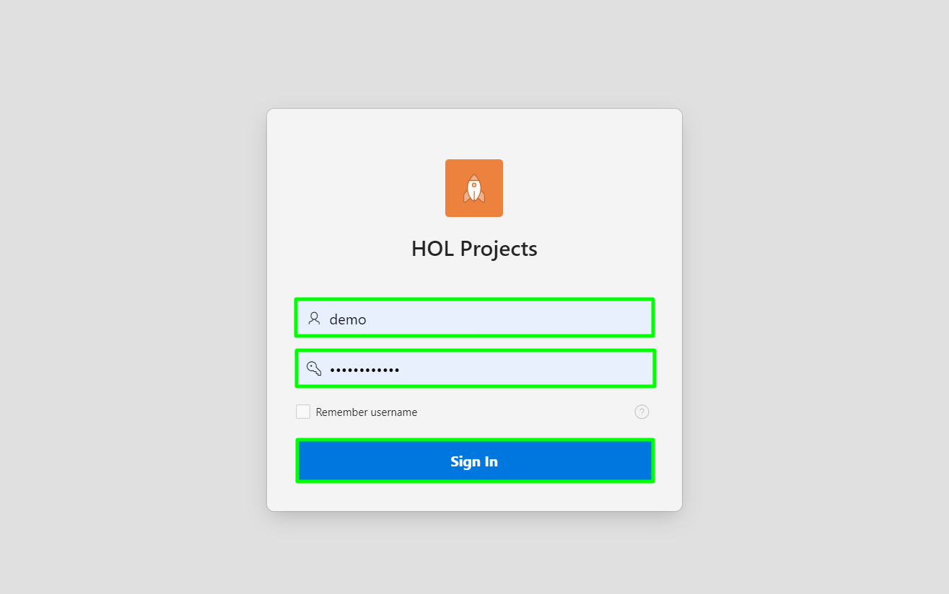

1. Take a moment to explore the pages that APEX created on top of the tables identified in the script.

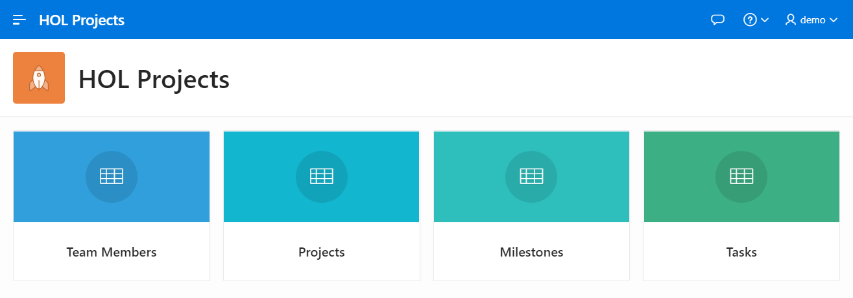

## Task 2: Add an Interactive Grid page and create records

Thus far, you've used high-level wizards to generate applications, first from a spreadsheet and then from a script. In this part, you will work at a lower level to add a new Interactive Grid page to the application. After that, you will use the new Interactive Grid to add some data to the HOL_TODOS table.

1. Return to the application home page in the Application Builder, then click **Create Page**.

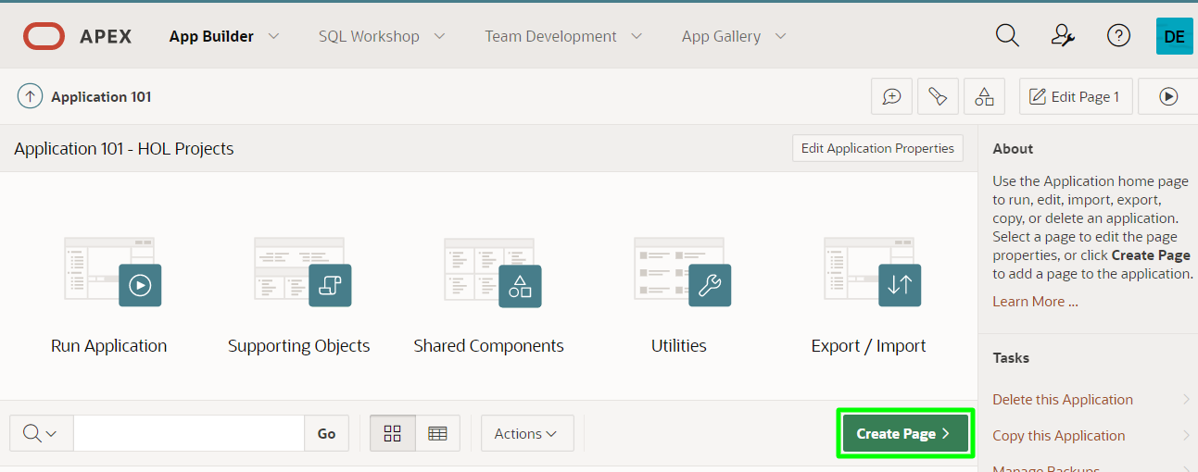

1. In the Create a Page dialog, click **Form**.

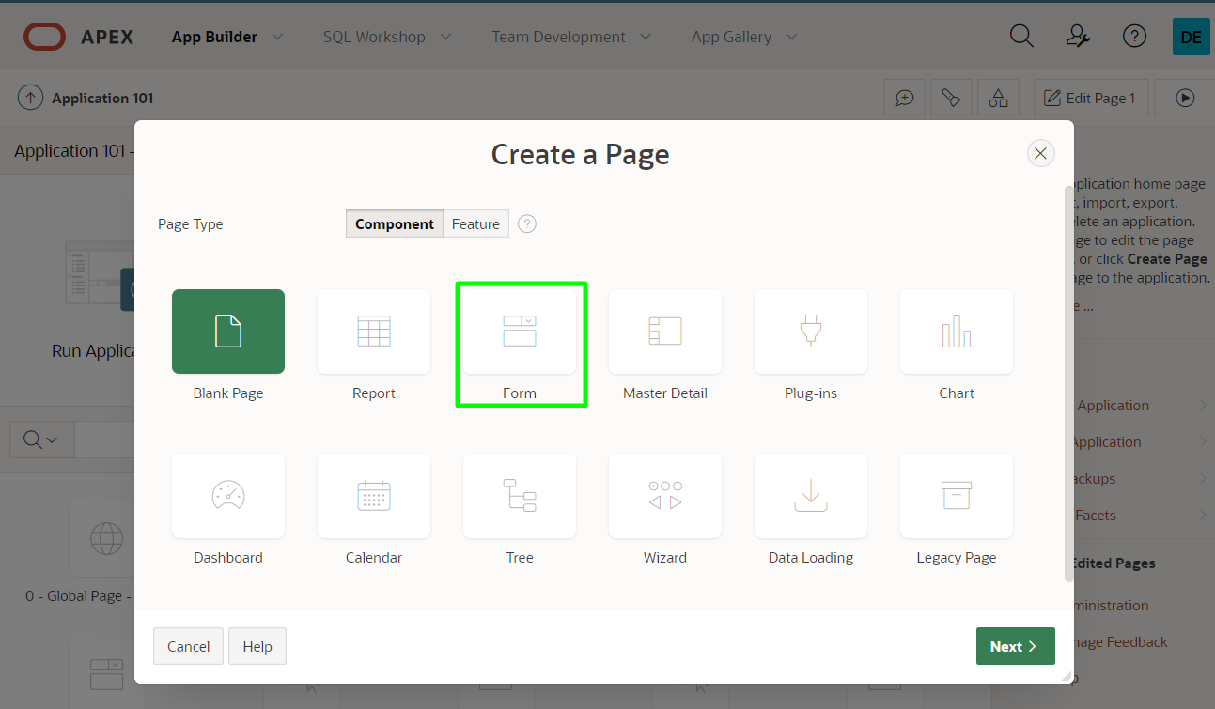

1. In the Create Page dialog, click **Editable Interactive Grid**.

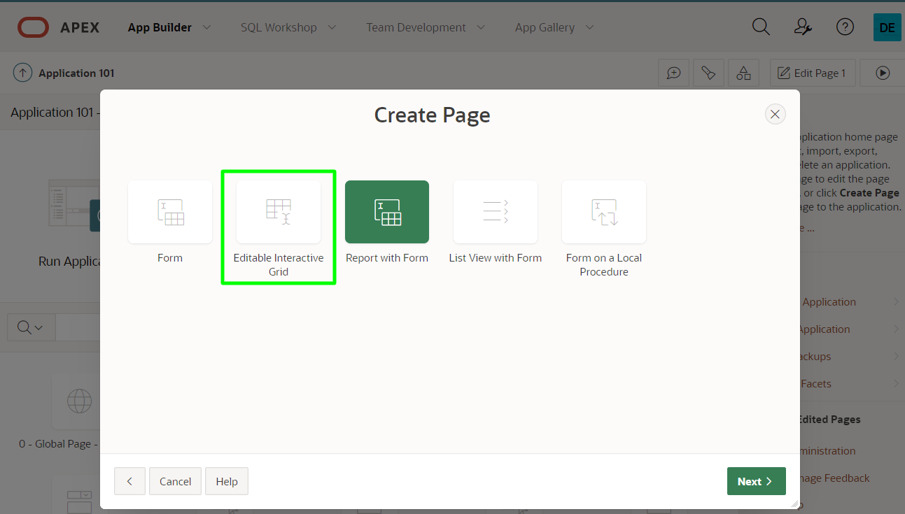

1. In the Create Interactive Grid - Page Attributes dialog, for Page Name enter **Todos**, then click **Next**.

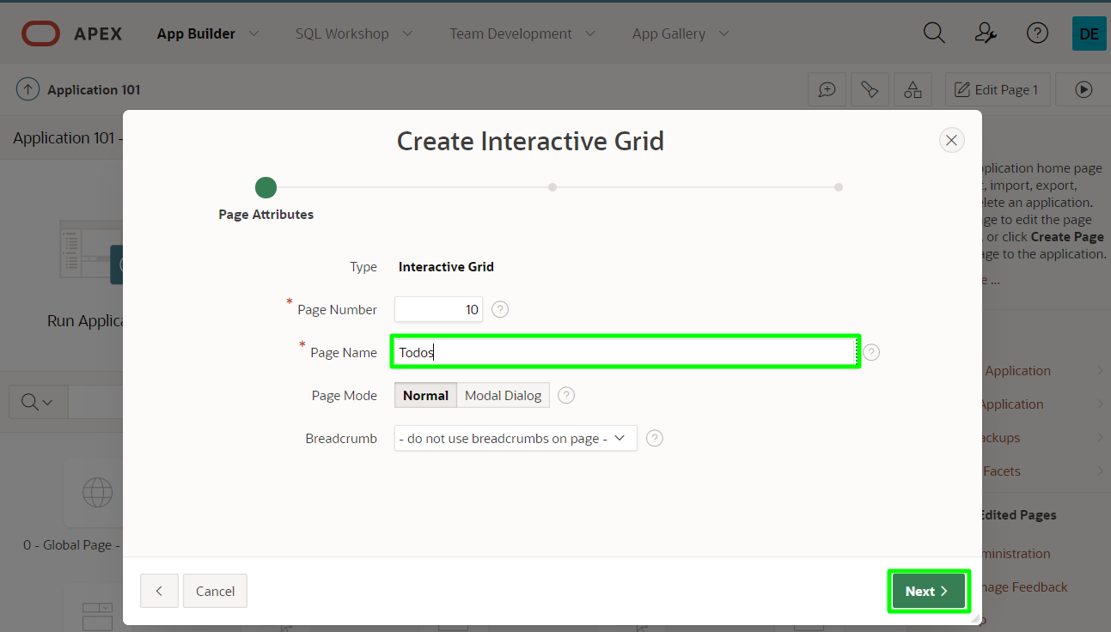

1. In the Navigation Menu dialog, for Navigation Preference, select **Create a new navigation menu entry**, then click **Next**.

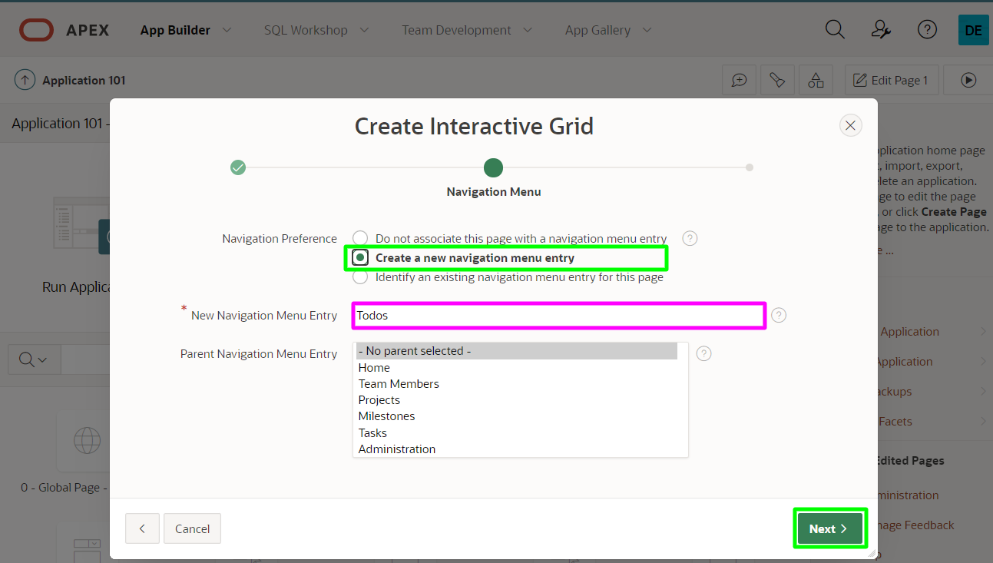

Note: The navigation menu entry defaults to the value you entered for Page Name.

1. In the Report Source dialog, for Table / View Name, select **HOL_TODOS (table)**, then click **Create**.

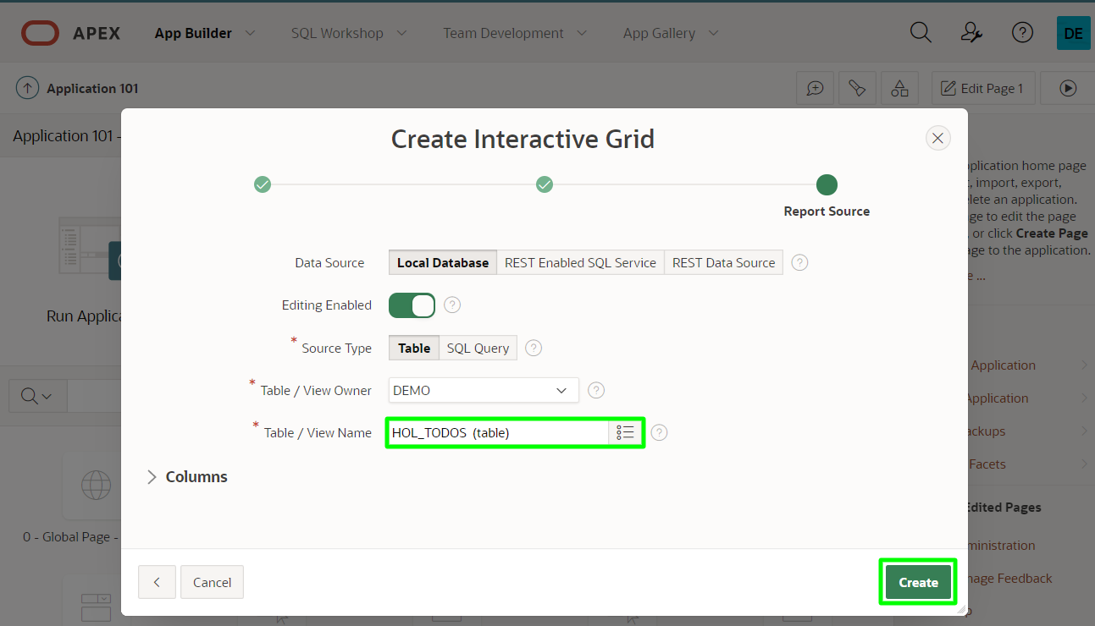

1. After the page is created, you will be redirected to the Page Designer (an IDE like interface) for the new page. To view the runtime for the new page, click the **Save and Run Page** button in the upper right-hand corner.

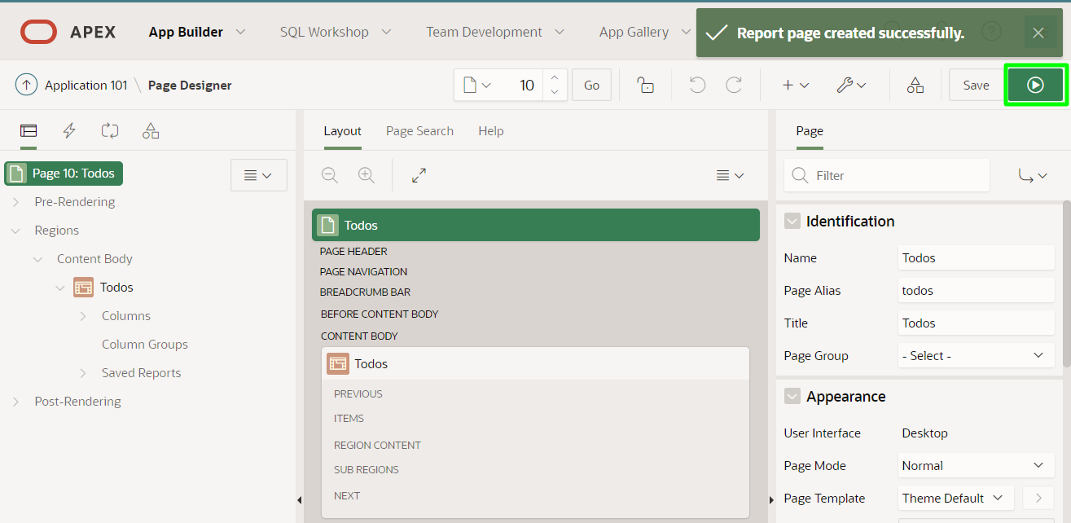

1. The new Interactive Grid page will open in the previous runtime browser tab or window.

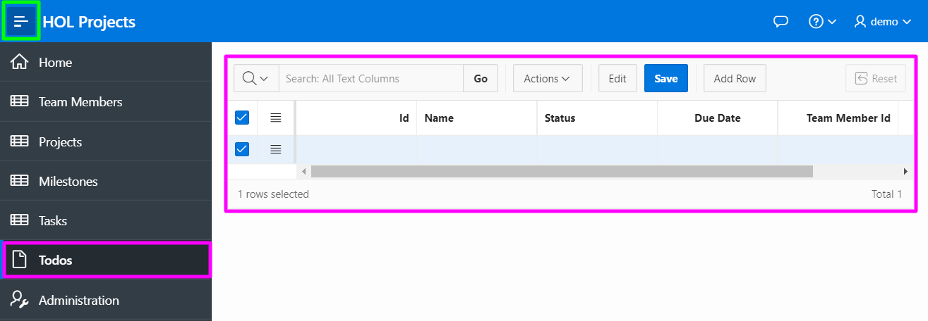

Note: A new navigation menu item has been added on the left as well.

1. Since there is no data in the HOL_TODOS table, the Interactive Grid displays one empty record by default. Use the **Add Row** button to add two more empty rows, populate the columns as follows:

| **Id** | **Name** |
| --- | --- |
| **1** | **Fix bugs** |
| **2** | **Test app** |
| **3** | **Deploy to production** |

1. Click **Save**.
2. 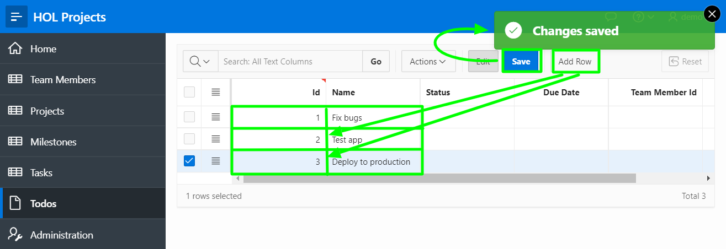
3. Note: Don't populate the additional columns yet, you will do that in the next part.

## Task 3: Enhance the Interactive Grid

A page in APEX is made up of various components, such as regions, items, and buttons. Once created, these components can be configured via the Page Designer. In this part, you will use the Page Designer to make some changes to the Interactive Grid region created in the previous part.

1. At the bottom of the runtime page, you will see the Developer Toolbar (only displayed to developers). Click **Edit Page 10** to return to the Page Designer for page 10 (your page number may be different).



1. The Page Designer has three panes, each of which contains different tabs. The default tab in the left pane is the Rendering tab, which displays the various components involved with rendering the page. Expand the columns under the **Todos** region and select **DUE_DATE**. The Property Editor tab in the right pane will display the properties for the selected column. Click the select icon for Format Mask.

In the Pick Format Mask dialog, click **12-JAN-2004**.

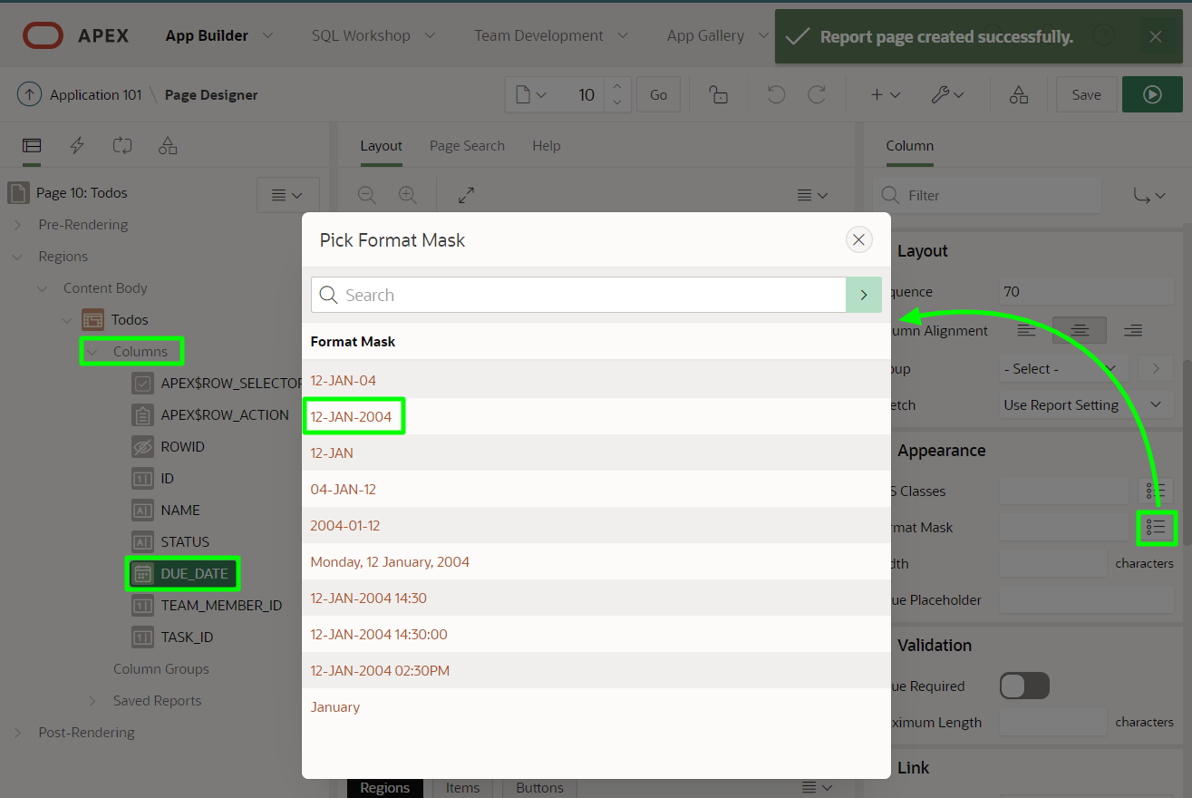

1. When it comes to foreign key columns, it's often best to use a List of Values item that displays one thing to the end user from a lookup table, but returns the foreign key value behind the scenes. This is known as a dynamic list of values. You can define a list of values directly on a page, or define them as a Shared Component that can be used on any page.

When you generated the application various list of values were created as Shared Components for use on other pages. You can reuse the List of Values defined for **TEAM_MEMBERS**.

In the Rendering tree (left pane), under Columns, select **TEAM_MEMBER_ID**.  
In the Property Editor (right pane), enter the following:

* + Identification > Type - select **Select List**
  + Heading > Heading - enter **Team Member**
  + List of Values > Type - select **Shared Component**
  + List of Values > List of Values - select **HOL_TEAM_MEMBERS.USERNAME**
  + List of Values > Display Extra Values - **Uncheck**

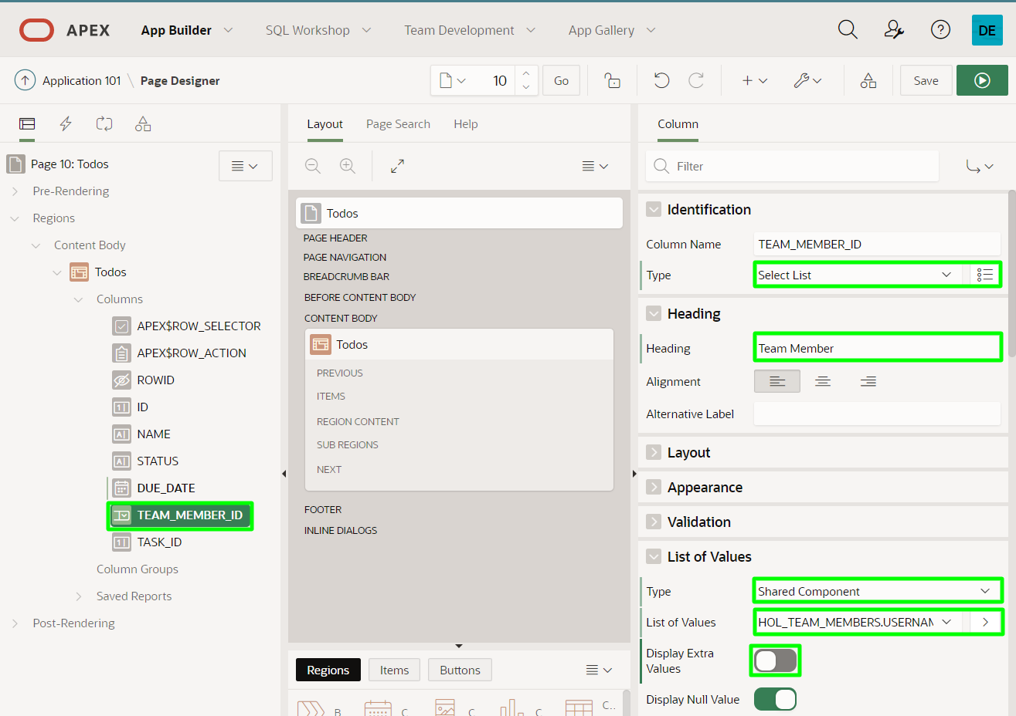

1. Unfortunately there is not already a List of Values defined for the HOL_TASKS table. Therefore, you will need to define a list of values using a SQL Statement.

In the Rendering tree (left pane), under Columns, select **TASK_ID**.  
In the Property Editor (right pane), enter the following:

* + Identification > Type - select **Select List**
  + Heading > Heading - enter **Task**
  + List of Values > Type - select **SQL Query**
  + List of Values > SQL Query - cut and paste the following
  + select name d, id r
  + from hol_tasks
  + order by name
  + List of Values > Display Extra Values - **Uncheck**

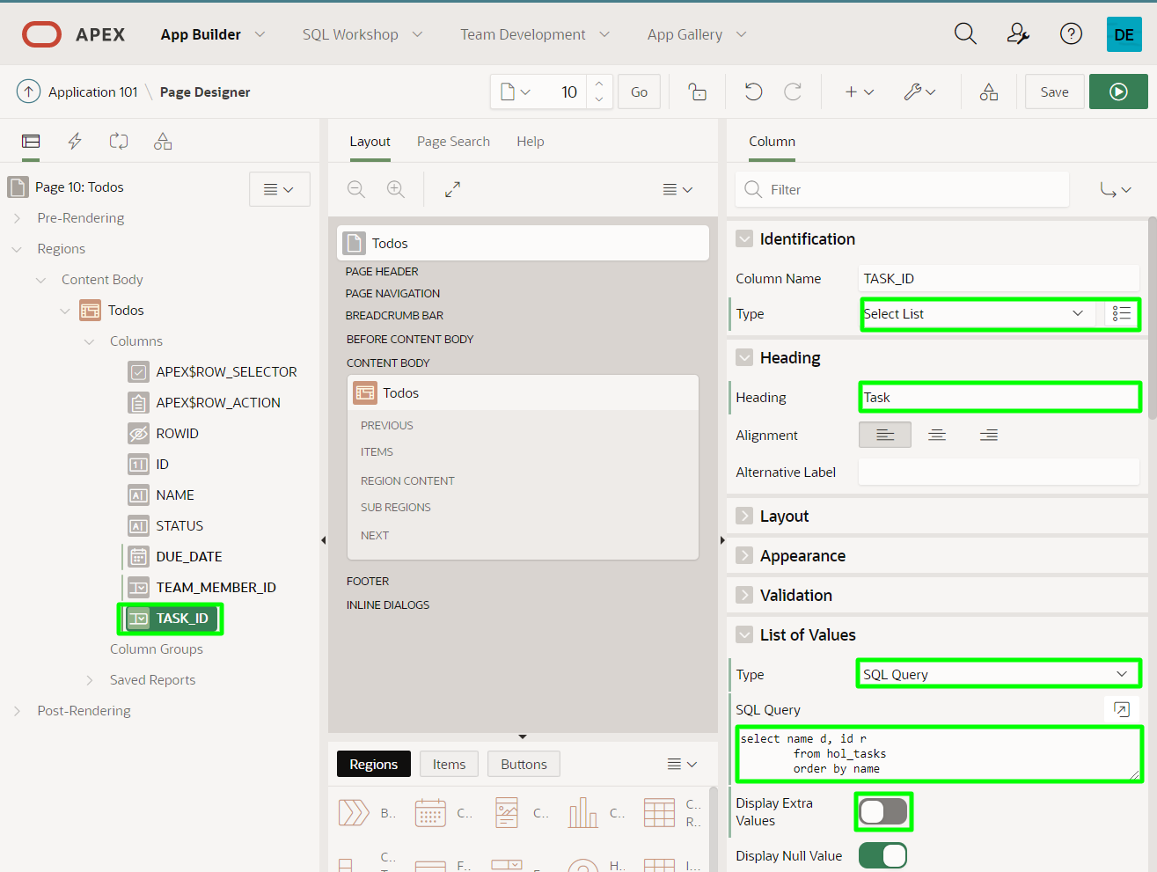

1. In addition to dynamic lists of values, it is sometimes beneficial to create a static list of values to constrain user input to a small set of allowable values. The STATUS column should only allow Pending, In Progress, or Complete.

In the Rendering tree (left pane), under Columns, select **STATUS**.  
In the Property Editor (right pane), enter the following:

* + Identification > Type - select **Select List**
  + List of Values > Type - select **Static Values**
  + List of Values > Display Extra Values - **Uncheck**
  + List of Values > Static Values - click **Display1, Display2**  
    In the Static Values dialog enter the following:

| **Display Value** | **Return Value** |
| --- | --- |
| Pending | Pending |
| In Progress | In Progress |
| Complete | Complete |

* + Click **Ok**.

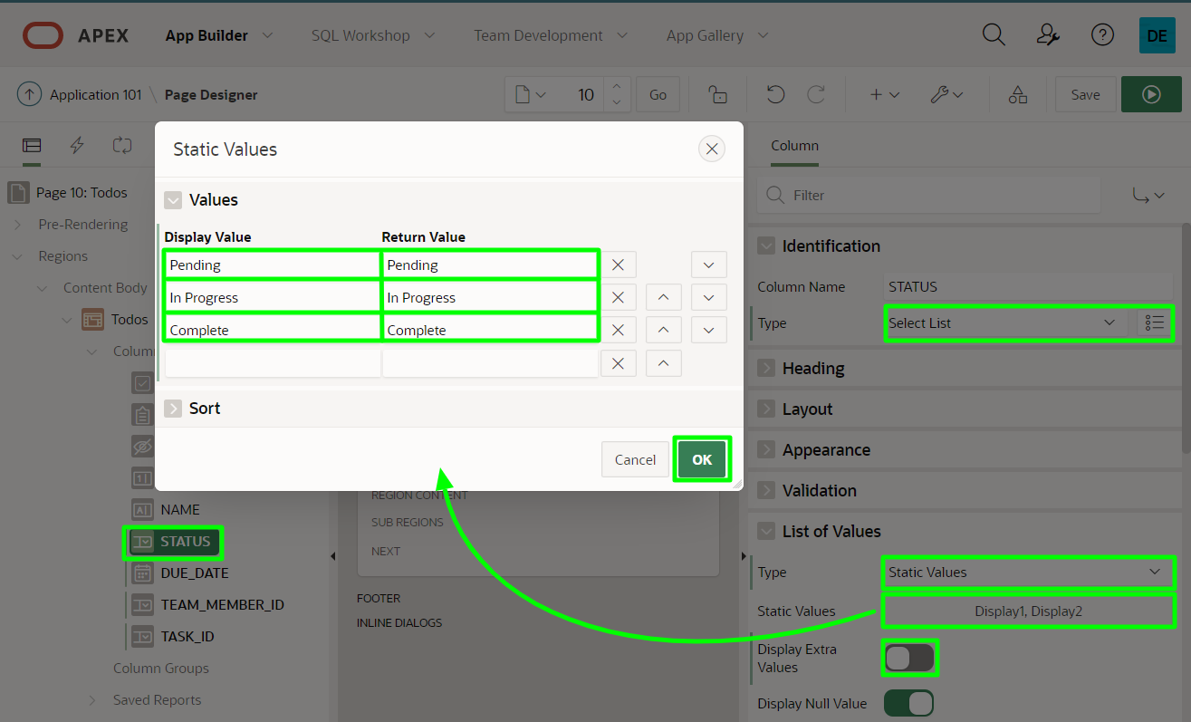

1. In the Page Designer toolbar, click **Save and Run Page**.

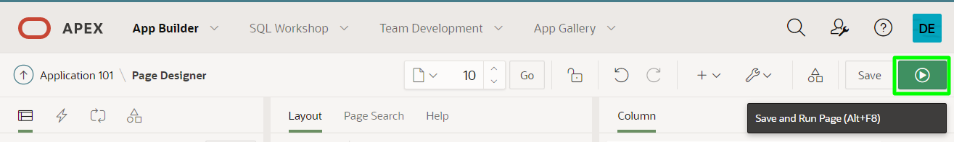

1. This will re-render the runtime page with the new settings. Try editing the last four columns to see how your updates affected the Interactive Grid.

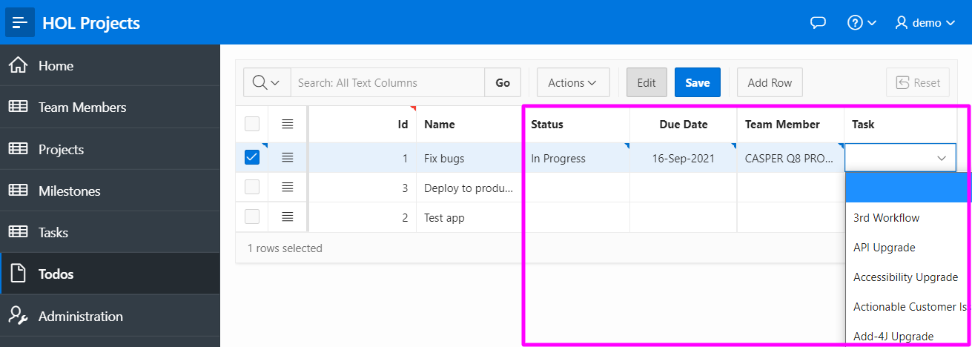

Note: The data for Team Members and Tasks is sample data created by Quick SQL, and may not be representative of the names your end users would enter. However, such data is invaluable for seeing data in the pages, and so forth.

## Task 4: Add a Calendar Page

APEX includes different components for viewing and working with data in different ways, including forms, reports, charts, and much more. One of the easiest ways to visualize data related to dates is with a calendar. In this part, you will create a new calendar page in your application to view data in the HOL_TASKS table. The HOL_TASKS table includes both a Start Date and End Date so you could choose to create a duration-based calendar, however, for this lab you are just going to use the Start Date.

1. Click the **Application 102** link (your app number may be different) in the Developer Toolbar. This will return you to the application's home page in the Application Builder.



1. From the Application home page, click **Create Page**.

In the Create a Page dialog, click **Calendar**.

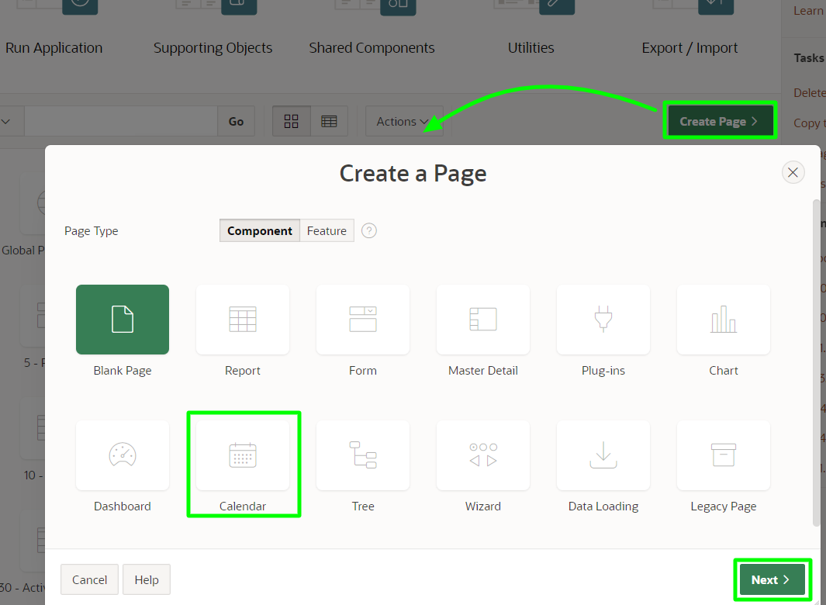

1. In the Create Page - Page Attributes dialog, for Page Name enter **Calendar**, then click **Next**.

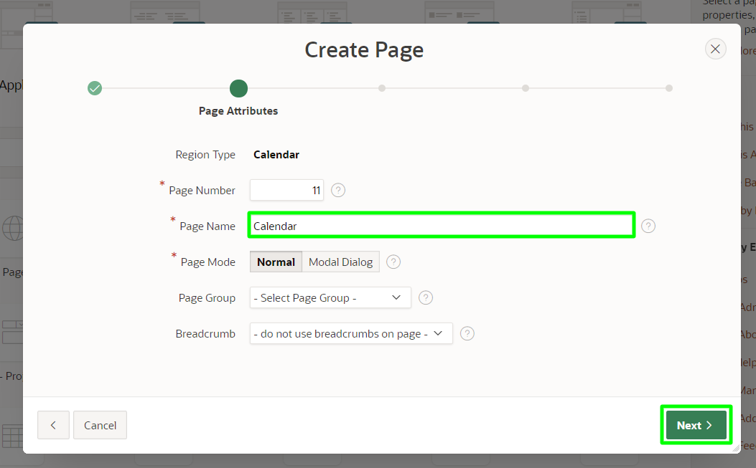

1. In the Navigation Menu dialog, for Navigation Preference, select **Create a new navigation menu entry**. Set Parent Navigation Menu Entry to **Tasks**, then click **Next**.

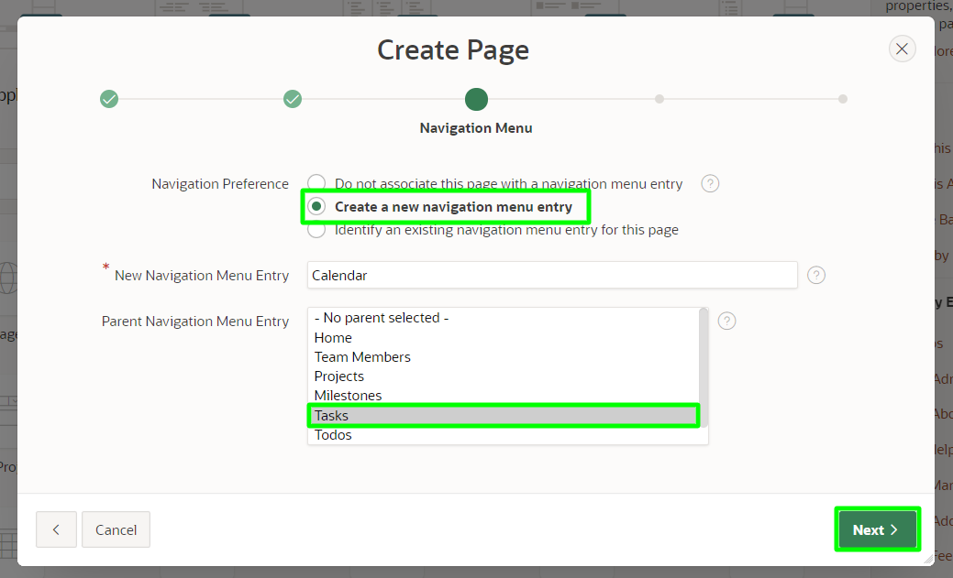

1. In the Source dialog, for Table / View Name, select **HOL_TASKS (table)**, then click **Next**.

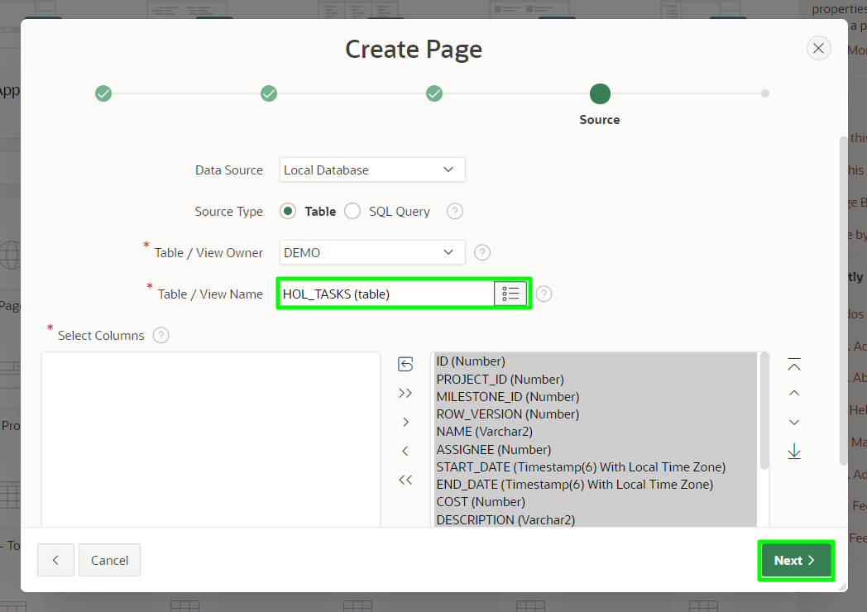

1. In the Settings dialog, for Display Column select **NAME**, then click **Create**.

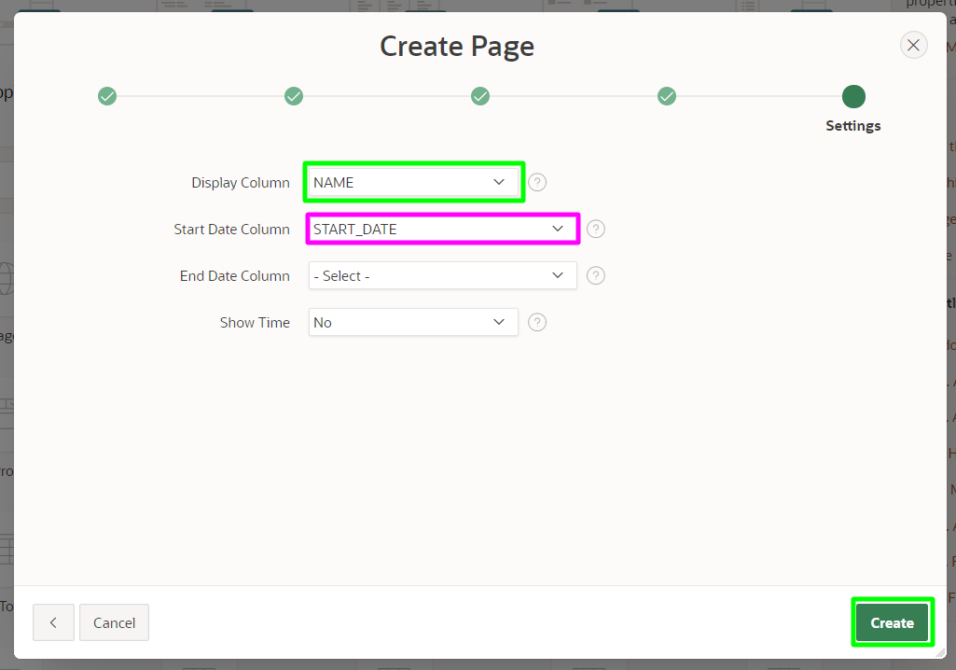

1. After the page is created, you will be redirected to the Page Designer for the new page.  
   In the Page Designer toolbar, click **Save and Run Page** to view the calendar at runtime.
2. Use the arrow buttons to change the months until you see some entries in the calendar. Also, note the new navigation menu entry under **Tasks**.

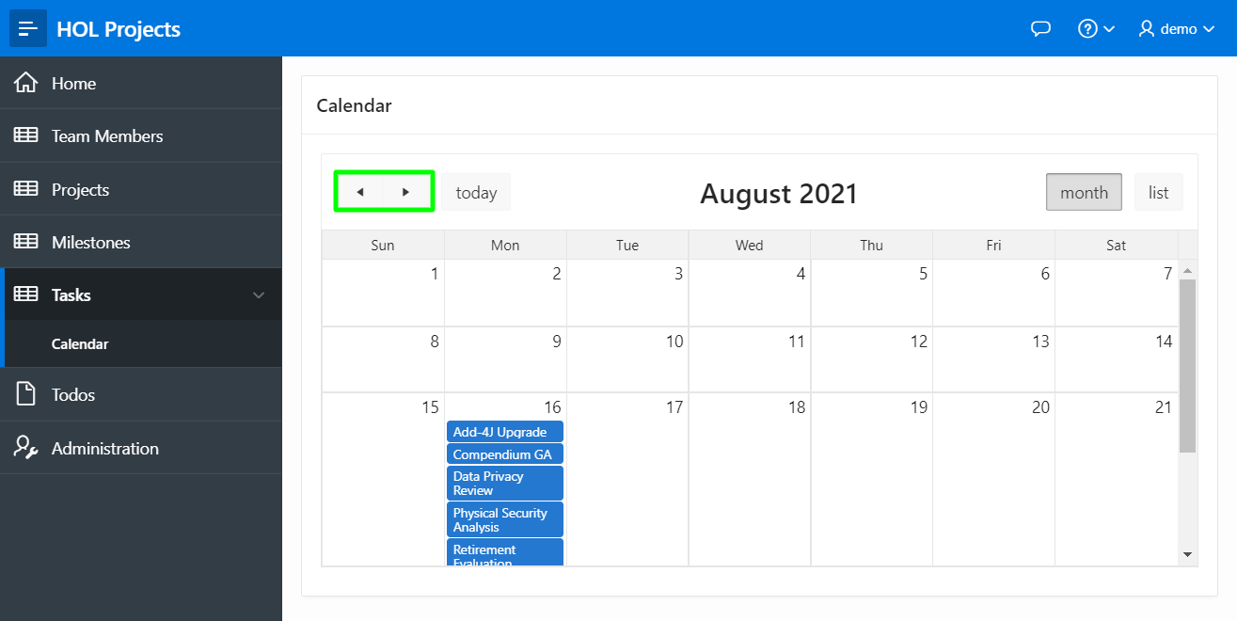

## Summary

You have completed the workshop, well done! At this point you should have a basic understanding of how the Autonomous Transaction Processing service, along with APEX and SQL Developer Web can be used to develop data driven applications with very little code.